Errata

At Dearborn™ Real Estate Education, we are proud of our reputation for providing the most complete, current, and accurate information in all our products. We are committed to ensuring the kind of quality you rely on. Please note the following changes, which will be reflected in the next printing of California Real Estate Practice 10th Edition.

To use this document, you will need to know which revision of the book you have. The revision is indicated on the copyright page, which is on the second page of the book.

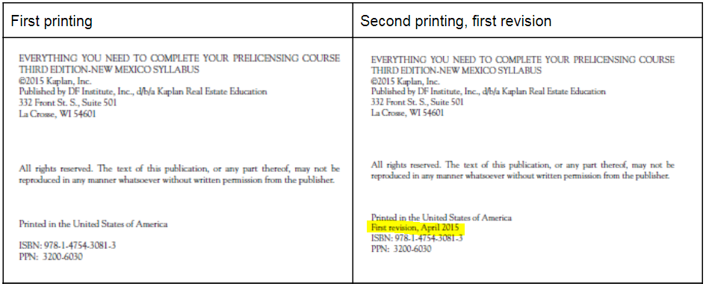

Page/Location | Reads Now | Should Be
481, Change in Ownership Statement | Any person acquiring an interest in property subject to local taxation must notify the county assessor by filing a change-in-ownership statement within 45 days of the date of recording or, if the transfer is not recorded, within 45 days of the date of transfer. | Any person acquiring an interest in property subject to local taxation must notify the county assessor by filing a change-in-ownership statement within 90 days of the date of recording or, if the transfer is not recorded, within 90 days of the date of transfer.
72, Trust Funds | Earned commissions must be withdrawn from the account within 30 days | Earned commissions must be withdrawn from the account within 25 days

