Errata

At Dearborn™ Real Estate Education, we are proud of our reputation for providing the most complete, current, and accurate information in all our products. We are committed to ensuring the kind of quality you rely on. Please note the following changes, which will be reflected in the next printing of California Real Estate Practice Workbook 5th Edition.

To use this document, you will need to know which revision of the book you have. The revision is indicated on the copyright page, which is on the second page of the book.

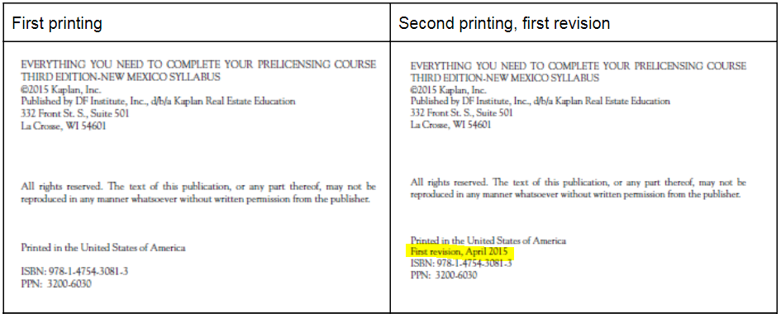

Page/Location | Reads Now | Should Be
Page 5, F. 5. a) | Deaths that have occurred on a property within three years from date of offer unless buyer asks a direct question, | Deaths that have occurred on a property more than three years prior to an offer to purchase property,
Page 19, question 1 | A. made to a consumer who has had contact  with the real estate professional within the  last 90 days.  B. made to a consumer who has had  negotiations with the real estate professional  within the last 18 months. | A. made to a consumer who has had contact with the real estate professional within the last 6 months.  B. made to a consumer who has purchased, rented, or leased property from the real estate professional within the last 18 months.
Page 41, Unit 2 Glossary Review #6 | The percentage of foreign buyers purchasing property in  the United States has been increasing. | The percentage of foreign buyers purchasing property in  the United States has been decreasing.

