Errata

At Dearborn™ Real Estate Education, we are proud of our reputation for providing the most complete, current, and accurate information in all our products. We are committed to ensuring the kind of quality you rely on. Please note the following changes, which will be reflected in the next printing of California Real Estate Finance 10th Edition.

To use this document, you will need to know which revision of the book you have. The revision is indicated on the copyright page, which is on the second page of the book.

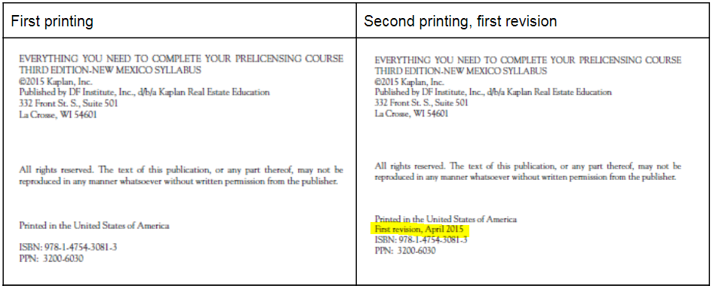

Page/Location | Reads Now | Should Be
108 | Based on the 2019 tax law, which allows anyone to make an annual tax-free  gift of $15,000, some parents can aid their children in purchasing a home.  A married couple could accept up to $60,000 in tax-free gifts—$15,000  from each parent to each of the children. | Based on the 2024 tax law, which allows anyone to make an annual tax-free gift of $18,000, some parents can aid their children in purchasing a home. A married couple could accept up to $72,000 in tax-free gifts—$18,000 from each parent to each of the children.
138, Figure 5.2 | Single Family $331,760 $765,600  Duplex 424,800 980,325  Triplex 513,450 1,184,925  Four Units 638,100 1,472,550 | Numbers updated with the following:  Standard  $498, 267  $637, 950  $771,125  $958,350  High Cost Area  $1,149,825  $1,472,250  $1,729,525  $2,211,600
147 | In 2020, the VA-guarantee is $127,600, or 25% of the current Freddie Mac loan limit of $510,400.  Because the lender regards this guaranteed amount the same as a 25% down payment, the lender will loan four times the guaranty for a single-family home. Thus, a lender would be willing to loan a qualified veteran borrower up to $417,000, four times the entitlement (up to $625,500 in high cost areas). | In 2024, the VA-guarantee is $127,600, or 25% of the current Freddie Mac loan limit of $510,400.  Because the lender regards this guaranteed amount the same as a 25% down payment, the lender will loan four times the guaranty for a single-family home.
192, paragraph 5 | ... the inducement to panic selling, also known as steering | ... the inducement to panic selling, also known as blockbusting
225, Secured Overnight Financing Rate (SOFR) | It appears that the Liboras index may be phased out and the newer index of SOFR may become the index of choice over time. | It appears that the Libor as index may be phased out and the newer index of SOFR may become the index of choice over time.
287 | Many financing arrangements include a due-on-sale clause, also known as a call clause, right-to-sell clause, acceleration clause, or an alienation clause. This condition stipulates that a borrower “shall not sell, transfer, encumber, assign, convey, or in any other manner dispose of the collateral property or any part thereof, or turn over the management or operation of any business on the collateral property to any other person, firm, or corporation without the express prior written consent of the lender.” | Many financing arrangements include a due-on-sale clause. This condition stipulates that a borrower “shall not sell, transfer, encumber, assign, convey, or in any other manner dispose of the collateral property or any part thereof, or turn over the management or operation of any business on the collateral property to any other person, firm, or corporation without the express prior written consent of the lender.”
289, paragraph 4 | Many financing arrangements include a due-on-sale clause, also known as a call clause, right-to-sell clause, acceleration clause, or an alienation clause. | Many financing arrangements include a due-on-sale clause.
360 | For example, the 2016 loan limits are as follows: | For example, the 2016 loan limits were as follows:
398, Trading on Seller's Equity | In effect, the seller would be securing the $35,000 cash plus the junior loan for $20,000 as agreed… | In effect, the seller would be securing the $35,000 cash plus the junior loan for $40,000 as agreed…
403 | The 2020 exemption from federal estate taxes is $11,580,000 per person. To pay estate taxes, then, a deceased’s estate would have to be evaluated at more than $23,160,000 net if owned as community property or jointly with a spouse. In other words, the gross value of the entire estate is estimated, debts against the estate, as well as all probate costs deducted, and the balance (or one-half if owned jointly or as community property) must exceed $11,580,000 before it is subject to federal estate taxes. It is possible that Congress will adopt law changes to Federal Estate Taxes. Consult with your tax professional. | The 2024 exemption from federal estate taxes is $13,610,000 per person. To pay estate taxes, then, a deceased’s estate would have to be evaluated at more than $27,220,000 net if owned as community property or jointly with a spouse. In other words, the gross value of the entire estate is estimated, debts against the estate, as well as all probate costs deducted, and the balance (or one-half if owned jointly or as community property) must exceed $13,610,000 before it is subject to federal estate taxes. It is possible that Congress will adopt law changes to Federal Estate Taxes. Consult with your tax professional.
404 | With proper planning, investors may be able to distribute their entire estates by utilizing tax-free gifts to avoid estate taxes. The 2019 law provides gift exemptions of up to $15,000 for each donor per donee per year. Thus, a husband and wife can gift $30,000 tax free each year to each heir. Gifts in excess of the exemptions are subject to tax at the federal level and at the state level. | With proper planning, investors may be able to distribute their entire estates by utilizing tax-free gifts to avoid estate taxes. The 2024 law provides gift exemptions of up to $18,000 for each donor per donee per year. Thus, a husband and wife can gift $36,000 tax free each year to each heir. Gifts in excess of the exemptions are subject to tax at the federal level and at the state level.
437, Figure 15.7 | One-family unit $417,000  Two-family unit $533,850  Three-family unit $645,300  Four-family unit $801,950 | One unit $766,550  Two unit $981,500  Three unit $1,186,350  Four unit $1,474,400

