Errata

At Dearborn™ Real Estate Education, we are proud of our reputation for providing the most complete, current, and accurate information in all our products. We are committed to ensuring the kind of quality you rely on. Please note the following changes, which will be reflected in the next printing of Essentials of New Jersey Real Estate, 16th Edition.

To use this document, you will need to know which revision of the book you have. The revision is indicated on the copyright page, which is on the second page of the book.

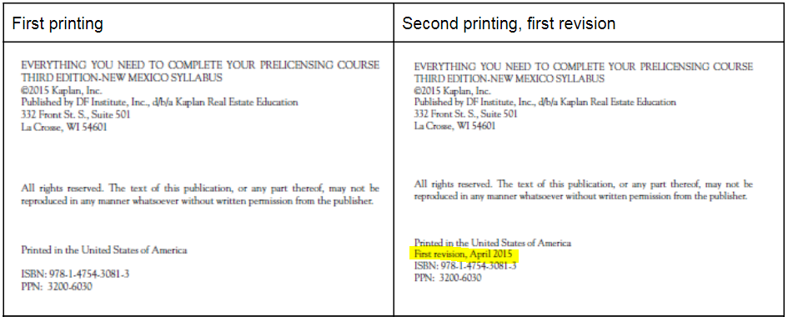

Page/Location | Reads Now | Should Be
25, Summary | Fines up to $25,000 are also possible. | [Delete sentence.]
110-111 | New Jersey law is silent as to the required number of years, although court cases appear to support a minimum of 20 years of adverse use. | New Jersey law is silent as to the required number of years, although court cases appear to support a minimum of 30 years of adverse use.
252, Question 8 | 8. What New Jersey lease, if properly acknowledged, may be recorded? | 8. What is the minimum term of a lease required by New Jersey law before a lease may be recorded?
278, Key Terms Review 1 | C. repayment plan, the equivalent of 14 monthly payments per year | C. repayment plan, the equivalent of 13 monthly payments per year
299, Key Terms Review 1 | H. straight loan for short building period | H. loans with interest-only payments, typically for less than six months
436, Question 61 | A. $720.50 | A. $654
440, Question 102 | B. $30,000 | B. $5,000
615, Answer Key, Unit 1 Review Questions | 15. D | 15. B
615, Answer Key, Unit 2 Review Questions | 12. A | 12. B
615, Answer Key, Unit 3 Key Terms Review 2 | 1. D  3. I | 1. I  3. D
616, Answer Key, Unit 3 Review Questions | 21. B | 21. D
616, Answer Key, Unit 5 Key Terms Review 2 | 4. K  11. D | 4. D  11. K
617, Answer Key, Unit 11 Key Terms Review 1 | 9. C | 9. B
618, Answer Key, Unit 11 Review Questions | 6. B  11. A | 6. A  11. D
618, Answer Key, Unit 13 Review Questions | 2. A | 2. B
619, Answer Key, Unit 15 Review Questions | 6. A | 6. B
620, Answer Key, Unit 17 Review Questions | 8. C | 8. B
620, Answer Key, Unit 17 Review Questions | 9. C | 9. A
620, Answer Key, Unit 17 Review Questions | 10. D | 10. C
620, Answer Key, Unit 18 Key Terms Review | 12. P | 12. B
621, Answer Key, Unit 21 Review Questions | 6. D | 6. A
624, Answer Key, Unit 1 Through 8 | 11. B | 11. A
625, Practice Test A | 32. B | 32. A

