Errata

At Dearborn™ Real Estate Education, we are proud of our reputation for providing the most complete, current, and accurate information in all our products. We are committed to ensuring the kind of quality you rely on. Please note the following changes, which will be reflected in the next printing of Today’s Real Estate Event Marketing in California.

To use this document, you will need to know which revision of the book you have. The revision is indicated on the copyright page, which is on the second page of the book.

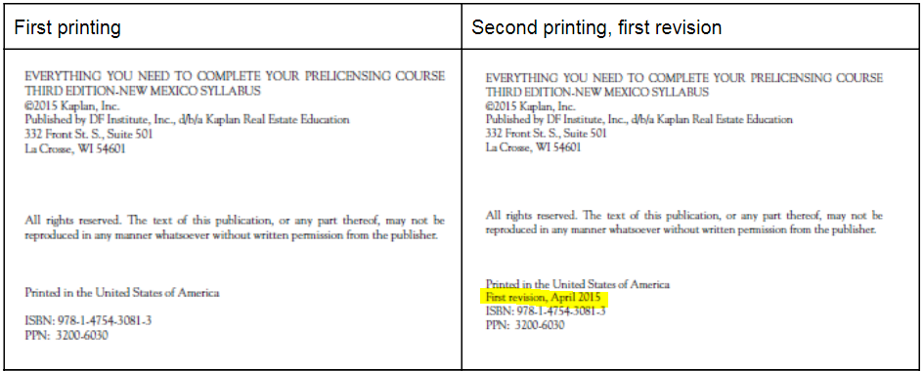

Page/Location | Reads Now | Should Be
56 | 7. True. Superior real estate agents should have specialized knowledge of the law, regulations, applicable codes of ethics, and standards of professional practice. | 7. False. Superior real estate agents should have specialized knowledge of the law, regulations, applicable codes of ethics, and standards of professional practice.
90 | 2. False. “Native advertising” is a related phenomenon that is called “fake news.” | 2. True. “Native advertising” is a related phenomenon that is called “fake news.”

