Errata

At Dearborn™ Real Estate Education, we are proud of our reputation for providing the most complete, current, and accurate information in all our products. We are committed to ensuring the kind of quality you rely on. Please note the following changes, which will be reflected in the next printing of Modern Real Estate in Pennsylvania, Fourteenth Edition.

To use this document, you will need to know which revision of the book you have. The revision is indicated on the copyright page, which is on the second page of the book.

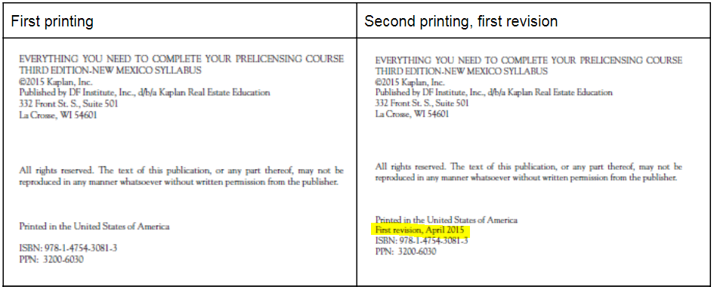

Page/Location | Reads Now | Should Be
112 | In some areas, taxes become due at the beginning of the current tax year and must be paid in advance (e.g., 2019 taxes must be paid at the beginning of 2018). | In some areas, taxes become due at the beginning of the current tax year and must be paid in advance (e.g., 2019 taxes must be paid at the beginning of 2019).
461 | Learning Objective: Describe the hearing process. | Learning Objective: Distinguish between the various types of lease payments.

First Revision
Page/Location | Reads Now | Should Be
222 | For instance, $750,000 is now excluded from capital gains tax for profits on the sale of a principal residence by married taxpayers who file jointly. Taxpayers who file singly are entitled to a $375,000 exclusion. | For instance, $500,000 is now excluded from capital gains tax for profits on the sale of a principal residence by married taxpayers who file jointly. Taxpayers who file singly are entitled to a $250,000 exclusion.
366 | A. An option  B. A contingency  C. An addendum  D. An amendment | A. An option  B. A contingency  C. An extension  D. An amendment
439 | 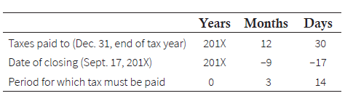 | 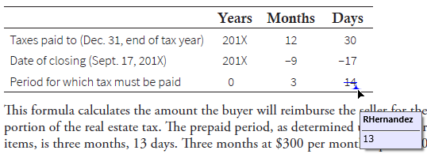
750, question 9 | (p. 222–223) | (p. 222)

