Errata

At Dearborn™ Real Estate Education, we are proud of our reputation for providing the most complete, current, and accurate information in all our products. We are committed to ensuring the kind of quality you rely on. Please note the following changes, which will be reflected in the next printing of Post-Licensing Education For Florida Real Estate Sales Associates.

To use this document, you will need to know which revision of the book you have. The revision is indicated on the copyright page, which is on the second page of the book.

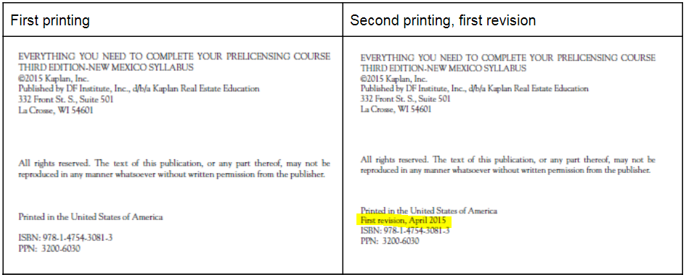

Page/Location | Reads Now | Should Be
121, Question #9 | - $20,000  - $28,900  - $16,300  - $29,000 | - $120,000  - $128,900  - $116,300  - $129,000
121, Question #10 | - $10,900  - $10,800  - $11,800  - $10,100 | - $26,900  - $27,800  - $28,800  - $26,100
121, Question #11 | - $1,700 subtracted  - $2,600 added  - $1,300 subtracted  - $900 subtracted | - $5,800 subtracted  - $6,600 added  - $5,300 subtracted  - $4,900 subtracted
121, Question #12 | - $14,500  - $16,300  - $17,100  - $15,400 | - $97,600  - $99,500  - $101,100  - $98,400
184, Question #4 | He has three days to close… | He has seven days to close…
340, Question #99 | d. 26 annual payments. | d. 26 weekly payments.
352, Question #9, last line | …mortgage balance - $28,898.40 seller’s equity; round to $28,900. | …mortgage balance - $128,898.40 seller’s equity; round to $128,900.
352, Question #11, first line | The answer is $5,800 subtracted… | The answer is $2,500 subtracted…
356, Question #4 | The answer is he has three days to close after restoration of utilities and insurance coverage becomes available. Under the FAR Residential Sale and Purchase Contract, the buyer has three days to close the transaction after  restoration of utilities and insurance coverage becomes available. | The answer is he has seven days to close after restoration of utilities and insurance coverage becomes available. Under the FAR Residential Sale and Purchase Contract, the buyer has seven days to close the transaction after  restoration of utilities and insurance coverage becomes available.
362, Question #10 | 10. d The answer is a signed and dated listing agreement. The closing agent does not need the listing agreement but must have the marital status of the parties, the legal description, and a property address. | 10. d The answer is Sellers’ Property Disclosure Statement. The closing agent does not need the Sellers’ Property Disclosure Statement but must have the marital status of the parties, the legal description, and a property address.
372, Question #99 | 99. d The answer is 26 annual payments. | 99. d The answer is 26 weekly payments

