Errata

At Dearborn™ Real Estate Education, we are proud of our reputation for providing the most complete, current, and accurate information in all our products. We are committed to ensuring the kind of quality you rely on. Please note the following changes, which will be reflected in the next printing of Florida Real Estate Principles, Practice, and Law 45th Edition.

To use this document, you will need to know which revision of the book you have. The revision is indicated on the copyright page, which is on the second page of the book.

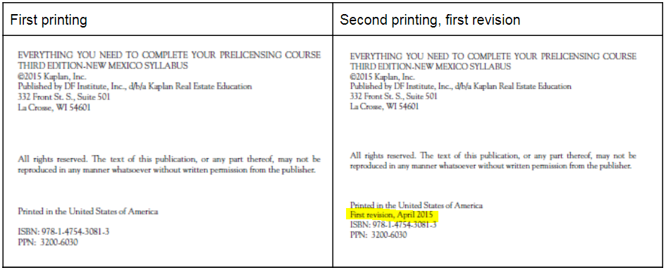

Page/Location | Reads Now | Should Be
Pg. 54, Unit 3, legal  reference, line 38 | 61J2-24.002(z) | 61J2-24.002(aa)
Pg. 78, Unit 4, PQ  20 | residential transaction | residential sale transaction
Pg. 490, Unit 2, PQ 11 | a, c | Attorneys, Florida Bar

IMPORTANT: ADDITIONAL HOMESTEAD EXEMPTION INFORMATION CONCERNING FLORIDA REAL ESTATE PRINCIPLES, PRACTICES, AND LAW 45E

In the 2022 Florida Legislative session, lawmakers passed changes to the additional homestead tax exemptions for the blind, disabled nonveterans, and surviving spouses who have not remarried that will start with the 2023 Ad Valorem Tax bill. We recommend that students calculate exemptions using both new and old amounts. The end-of-course exam will reflect the old calculations; however, the state exam will likely use the new $5,000 amount Below will show the changes in red for the pages in the 45th edition of PPL for sales associates.

Unit 18: Taxes Affecting Real Estate; page 410 (lines 17-19) thru page 410 (figure 18.3) and examples

Additional Homestead Tax Exemptions. Florida law provides certain additional exemptions
from the assessed value of homesteaded property (see Figure 18.3). Florida statute
dictates what proof must be submitted to qualify for the additional exemptions.

F I G U R E 1 8.3 ■ Homesteaded Property Special Exemptions
Additional Exemption on Homestead Additional Amount Deducted From
Assessed Value
Surviving spouse who has not remarried $500 changes to $5,000 January 1, 2023
Blind person $500 changes to $5,000 January 1, 2023
Totally and permanently disabled nonveteran $500 changes to $5,000 January 1, 2023
Totally and permanently disabled quadriplegic Homestead property 100% tax exempt
Totally and permanently disabled first responder Homestead property 100% tax exempt
(Applies also to surviving spouse)

Cumulative Homestead Tax Exemptions. The taxable value of a homesteaded property is calculated by totaling all the tax exemptions that apply to the homeowners and deducting the applicable exemptions from the assessed value. [see pg. 411, lines 5-15]
E X A M P L E: What is the total homestead exemption for a widower with an assessed value of more than $75,000 on a qualifying homesteaded property?
$50,000 homestead exemption+$500 [$5000 1/1/2023] surviving spouse additional exemption = $50,500 [$55,000 as of 1/1/2023]
E X A M P L E: What is the total homestead exemption for a blind surviving spouse with an assessed value of greater than $75,000 on a qualifying homesteaded property?
$50,000+$500 [$5000 1/1/2023] blind exemption +$500 [$5000 1/1/2023] surviving spouse exemption = $51,000 [$60,000 1/1/2023]

Page 424, Summary of Important points, line 15, An additional $500 [$5,000 after 1/1/2023] exemption from the assessed value of homesteaded property is available to widows and widowers, legally blind persons and nonveterans who are totally and permanently disabled.

