Errata

At Dearborn™ Real Estate Education, we are proud of our reputation for providing the most complete, current, and accurate information in all our products. We are committed to ensuring the kind of quality you rely on. Please note the following changes, which will be reflected in the next printing of TEXAS PROMULGATED FORMS FIFTH EDITION.

To use this document, you will need to know which revision of the book you have. The revision is indicated on the copyright page, which is on the second page of the book.

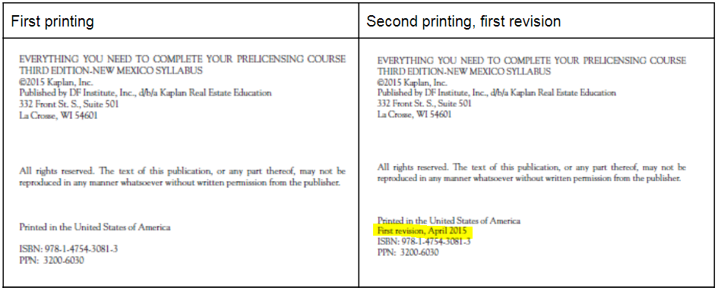

Page/Location | Reads Now | Should Be
Unit 7, Page 117-135 |  | New Form 59-0 Notice to Purchaser of Special Taxing or Assessment District  https://www.trec.texas.gov/sites/default/files/59-0.pdf

