Errata

At Dearborn™ Real Estate Education, we are proud of our reputation for providing the most complete, current, and accurate information in all our products. We are committed to ensuring the kind of quality you rely on. Please note the following changes, which will be reflected in the next printing of TEXAS PROMULGATED FORMS SUPPLEMENT FOURTH EDITION.

To use this document, you will need to know which revision of the book you have. The revision is indicated on the copyright page, which is on the second page of the book.

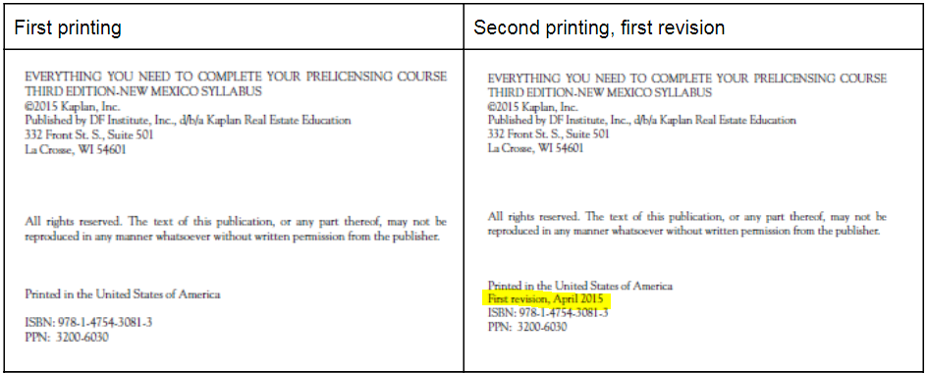

Page/Location | Reads Now | Should Be
P55-64 Figure 6 | Form 9-15 | Updated form 9-16 can be accessed here: https://www.trec.texas.gov/forms/unimproved-property-contract-0
Page 103 |  | New Form 59-0 Notice to Purchaser of Special Taxing or Assessment District  https://www.trec.texas.gov/sites/default/files/59-0.pdf
P104 Figure 34 | Consumer Protection Notice | Updated form found here: https://www.trec.texas.gov/sites/default/files/pdf-forms/CN%201-5_0.pdf
P105 figure 35 | Disclosure of Relationship with Residential Service Company | Updated form found here: https://www.trec.texas.gov/forms/disclosure-relationship-residential-service-company
P107 figure 36 | Notice to Prospective Buyer | Updated form found here: https://www.trec.texas.gov/forms/notice-prospective-buyer-0
P108, figure 37 | Seller’s Disclosure Notice | Updated form found here: https://www.trec.texas.gov/forms/sellers-disclosure-notice-0

