Errata

At Dearborn™ Real Estate Education, we are proud of our reputation for providing the most complete, current, and accurate information in all our products. We are committed to ensuring the kind of quality you rely on. Please note the following changes, which will be reflected in the next printing of Property Management and Managing Risk, 6E.

To use this document, you will need to know which revision of the book you have. The revision is indicated on the copyright page, which is on the second page of the book.

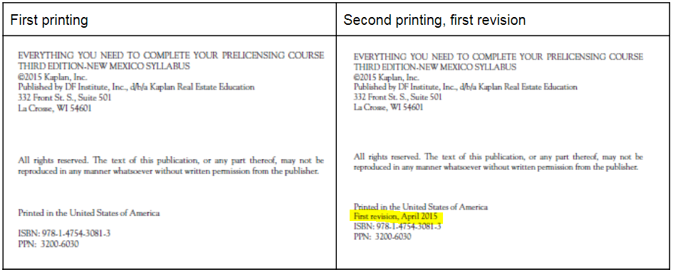

Page/Location | Reads Now | Should Be
Page 30, Unit 2 Review Questions | 2. If the principal asks the manager to violate the law, the agent must do so under the fiduciary duty of obedience.  A. True  B. False | 2. If the principal asks the manager to violate the law, the agent must do so under the fiduciary duty of obedience.  A. True  B. False
Page 30, Unit 2 Review Questions | 3. A property manager may commingle client funds with the regular office funds.  A. True  B. False | 3. A property manager may commingle client funds with the regular office funds.  A. True  B. False
Page 30, Unit 2 Review Questions | 6. The uniform property management compensation rate recommended by BOMA is a valuable standard for the property manager to use in negotiating a fee structure.  A. True  B. False | 6. The uniform property management compensation rate recommended by BOMA is a valuable standard for the property manager to use in negotiating a fee structure.  A. True  B. False
Page 63, Unit 4 Review Questions | 10. The Americans with Disabilities Act (ADA) requires that owners of commercial properties remodel or modify their units to achieve accessibility, regardless of the cost.  A. True  B. False | 10. The Americans with Disabilities Act (ADA) requires that owners of commercial properties remodel or modify their units to achieve accessibility, regardless of the cost.  A. True  B. False
Page 83, Unit 5 Review Questions | 3. The occupant of a condominium unit is a  shareholder in a corporation that owns the underlying real property.  A. True  B. False  4. Individual ownership of an apartment, coupled with undivided common ownership of common areas, is characteristic of a cooperative.  A. True  B. False  5. Property managers are well advised to insist on long-term contracts with condominium boards to protect their interests.  A. True  B. False | 3. The occupant of a condominium unit is a  shareholder in a corporation that owns the underlying real property.  A. True  B. False  4. Individual ownership of an apartment, coupled with undivided common ownership of common areas, is characteristic of a cooperative.  A. True  B. False  5. Property managers are well advised to insist on long-term contracts with condominium boards to protect their interests.  A. True  B. False
Page 83, Unit 5 Review Questions | 10. Condominium owners’ pro rata share for their individual units is determined by the ratio the square footage of the unit bears to the total square footage of all units in the project.  A. True  B. False | 10. Condominium owners’ pro rata share for their individual units is determined by the ratio the square footage of the unit bears to the total square footage of all units in the project.  A. True  B. False
Page 100, Unit 6 Review Questions | 3. The owner of the property is responsible for purchasing insurance to cover the tenant’s property.  A. True  B. False | 3. The owner of the property is responsible for purchasing insurance to cover the tenant’s property.  A. True  B. False
Page 100, Unit 6 Review Questions | 7. Flood insurance is ALWAYS a separate insurance policy.  A. True  B. False | 7. Flood insurance is ALWAYS a separate insurance policy.  A. True  B. False
Page 115, Unit 4 Review Questions Answer Key (T/F) | 10. B In a few circumstances, if the modifications are too costly or extremely difficult to make, an exemption may be granted. However, no one should assume that an exemption will be granted. | 10. B In a few circumstances, if the modifications are too costly or extremely difficult to make, an exemption may be granted. However, no one should assume that an exemption will be granted.
By removing the questions indicated in Units 2, 5, and 6, the answer keys for the true/false questions in the back of the book will have the answers in the correct order.

