Errata

At Dearborn™ Real Estate Education, we are proud of our reputation for providing the most complete, current, and accurate information in all our products. We are committed to ensuring the kind of quality you rely on. Please note the following changes, which will be reflected in the next printing of California Real Estate Law 10th Edition.

To use this document, you will need to know which revision of the book you have. The revision is indicated on the copyright page, which is on the second page of the book.

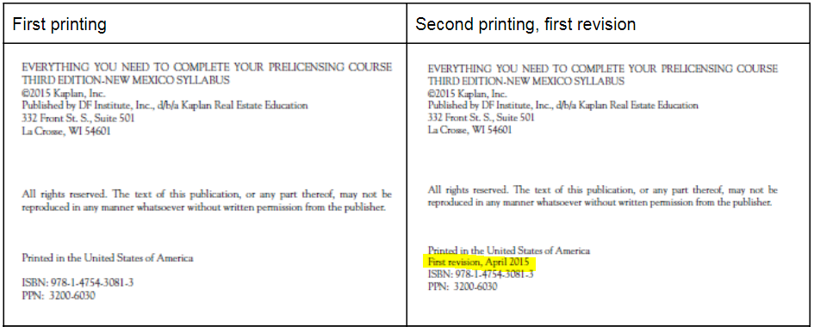

Second printing, first revision
Page/Location | Reads Now | Should Be
73, Death on the Premises | California law formerly provided that an agent had no duty to disclose death on the premises after three years. In 2016, the law was amended to provide there is no cause of action for the failure to disclose death on the premises or cause of death with no time limitations as death is not considered to be a material fact requiring disclosure.  If a buyer inquired as to any deaths on the property or cause of death, the agent would have to answer truthfully as to any information the agent had. A fake statement could subject an agent to liability even though the agent had no duty to disclose the information.  Because a buyer's agent has greater disclosure obligations to a buyer, a court might determine that deaths or assaults on the premises, that could reasonably be expected to influence a purchase, must be disclosed. | "An owner of real property, their agent, or an agent of a buyer or tenant, is not required to disclose either of the following:  1) A death upon the property, or the manner of death, where the death occurred more than three years prior to the date a person offers to purchase, lease, or rent the property.  2) An occupant of the property was living with HIV or died from AIDS-related complications.  3) This law does not immunize an owner or his or her agent from making an intentional misrepresentation in response to a direct inquiry from a transferee or a prospective transferee of real property, concerning deaths on real property.
553, unit 12, item 10 | (d) Correlative user refers to underground water. p. 393 | (d) A dominant tenement is an easement that "dominates" another parcel of land by receiving the benefit of the easement. p. 393

Third printing, 2nd revision
Page/Location | Reads Now | Should Be
550, Unit 4, items 9 | 9. (d) There is a limit as to what the recovery fund will pay. p. 103 | 9. (d) There is a limit as to what the recovery fund will pay. p. 104
551, Unit 5, items 14 | 14. (c) p. 161 | 14. (c) p. 160

