Errata

At Dearborn™ Real Estate Education, we are proud of our reputation for providing the most complete, current, and accurate information in all our products. We are committed to ensuring the kind of quality you rely on. Please note the following changes, which will be reflected in the next printing of Modern Real Estate Practice in New York for Salespersons 14E.

To use this document, you will need to know which revision of the book you have. The revision is indicated on the copyright page, which is on the second page of the book.

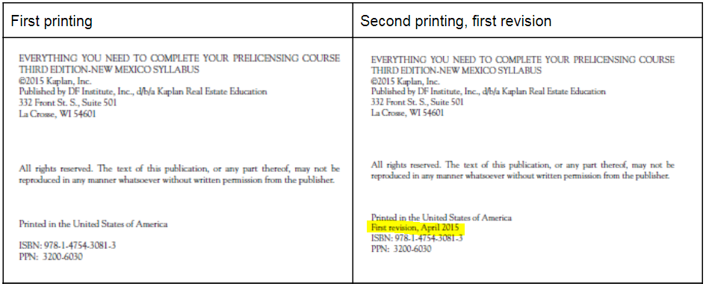

Page/Location | Reads Now | Should Be
Vii, Special Acknowledgment | Her contributions  are still evident in this thirteenth edition, | Her contributions  are still evident in this fourteenth edition, a
p.86-91, Property Condition Disclosure Statement | Replaced | New required form located here:  https://dos.ny.gov/important-updates-licensing?utm_medium=email&utm_name=&utm_source=govdelivery
P400, Figure 17.1 | The chart said that only NY City has as protected classes has as protected classes alienage/citizenship, lawful source of income and survivors of domestic violence, sex offenses and stalking. | The chart should be updated so that the word “Yes” is under Lawful source of income, Citizenship, and Survivors of domestic violence.
P419 | To assist in planning and implementing policy and guidelines on cultural awareness and  as a prerequisite to the same, it is advised that before implementation, a review of current  discrimination laws and what would create discriminatory practices take place. | To assist in planning and implementing policy and guidelines on cultural awareness, it is advised that before implementation, one should review current discrimination laws and learn more about the causes of discriminatory practices.
P478 | Repeat sentence: Returns on invested capital are generally based on level of risk associated with an investment. | Deleted repeat sentence

