Errata

At Dearborn™ Real Estate Education, we are proud of our reputation for providing the most complete, current, and accurate information in all our products. We are committed to ensuring the kind of quality you rely on. Please note the following changes, which will be reflected in the next printing of Real Estate Fundamentals, Tenth Edition

To use this document, you will need to know which revision of the book you have. The revision is indicated on the copyright page, which is on the second page of the book.

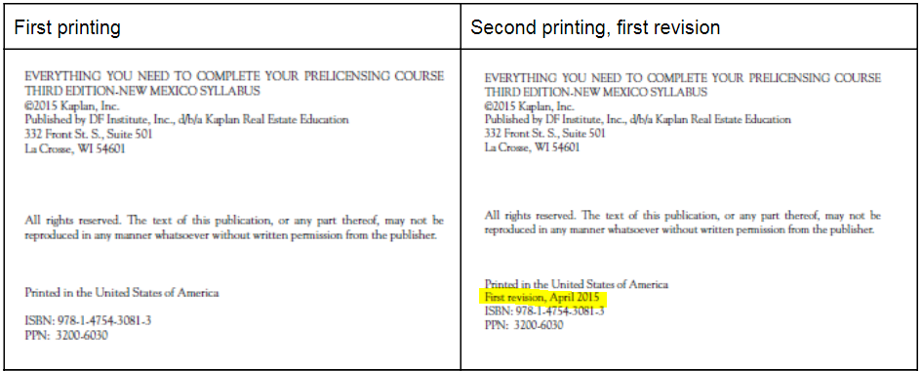

Page/Location | Reads Now | Should Be
208 | $150,000 × 4.5% = $6,000 annual interest | $150,000 × 4.5% = $6,750 annual interest
266, question 2 | b. a developer | b. a subdivider
368, Unit 1 Review Questions | 1. A | 1. B
297, Unit 18 Review Questions | The sellers have indicated that they are selling their home “as is.” In this situation, the sellersA. have no intention of making any repairs.  B. are not required to disclose any problems.  C. can avoid legal liability for nondisclosure.  D. rely on the law to avoid disclosure. | Over the past year, a local residential area has  been experiencing a decrease in real estate value  of approximately 3%. If a house sold last year for  $176,000, what would it MOST likely sell for  this year?  a. $5,280  b. $170,873  c. $173,000  d. $181,280
388 Unit 18 Review Questions | 7. B. 170,720. | 7. B. 170,873

