Errata

At Dearborn™ Real Estate Education, we are proud of our reputation for providing the most complete, current, and accurate information in all our products. We are committed to ensuring the kind of quality you rely on. Please note the following changes, which will be reflected in the next printing of Fundamentals of Real Estate Appraisal 14th Edition.

To use this document, you will need to know which revision of the book you have. The revision is indicated on the copyright page, which is on the second page of the book.

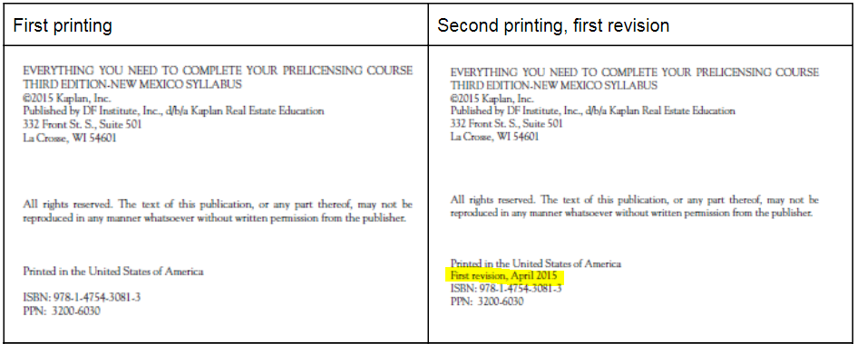
First revision, 2nd printing
Page/Location | Reads Now | Should Be
413, Unit 6 Review Answers, Item 5 | 5. C. Value of property B: $480,000 – $36,000 = $444,000 | 5. D. Value of property B: $480,000 – $36,000 = $444,000

