Errata

At Dearborn™ Real Estate Education, we are proud of our reputation for providing the most complete, current, and accurate information in all our products. We are committed to ensuring the kind of quality you rely on. Please note the following changes, which will be reflected in the next printing of Essentials of New Jersey Real Estate 15th Edition.
bri
To use this document, you will need to know which revision of the book you have. The revision is indicated on the copyright page, which is on the second page of the book.

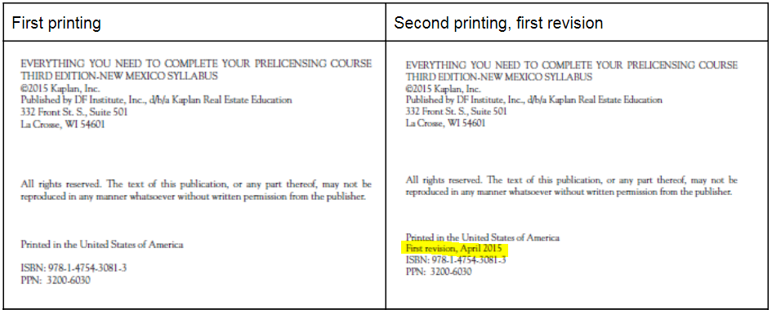

Page/Location | Reads Now | Should Be
90, Key Terms Review 1 | ______ 1. Accretion  ______ 2. Air rights  ______ 3. Littoral rights  ______ 4. Avulsion  ______ 5. Bundle of rights  ______ 6. Chattels  ______ 7. Corporeal  ______ 8. Devise  ______ 9. Emblements  ______ 10. Riparian rights  ______ 11. Fixture  ______ 12. Hereditament  ______ 13. Improvement | ______ 1. Accretion  ______ 2. Air rights  ______ 3. Alluvion  ______ 4. Avulsion  ______ 5. Littoral rights  ______ 6. Chattels  ______ 7. Corporeal  ______ 8. Devise  ______ 9. Emblements  ______ 10. Erosion  ______ 11. Fixture  ______ 12. Hereditament  ______ 13. Riparian rights
319 | Instead, they should encourage the questioner to consult the Division of Land Resource Licensees should avoid answering any questions about the viability using any site for building a structure. Instead, they should encourage the questioner to consult the Division of Land Resource Protection. | [Delete duplicate text]
586, Answer Key, Unit 4, Review Question #10 | 10. A | 10. C

