Errata

At Dearborn™ Real Estate Education, we are proud of our reputation for providing the most complete, current, and accurate information in all our products. We are committed to ensuring the kind of quality you rely on. Please note the following changes, which will be reflected in the next printing of Florida Real Estate Broker's Guide.

To use this document, you will need to know which revision of the book you have. The revision is indicated on the copyright page, which is on the second page of the book.

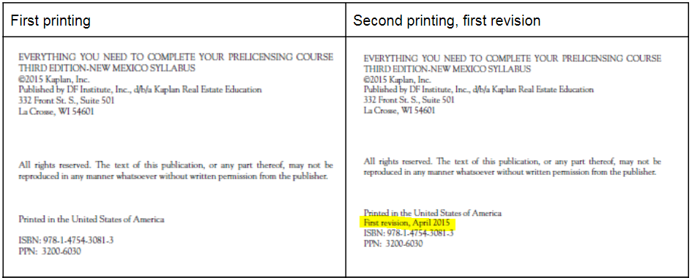

Page/Location | Reads Now | Should Be
378 | The IRS requires a buyer of property owned by a foreign investor to withhold 10% of the purchase price of the amount realized on the sale, and to deposit the sum with the IRS within 30 days. If the sale is greater than $1,000,000, the withholding rate is 15%. The sale of a personal residence is exempt if the amount realized is not greater than $300,000. | The Foreign Investment in Real Property Tax Act (FIRPTA) requires a buyer of property owned by a foreign investor to withhold 15% of the amount realized on the sale. The sale of a personal residence is exempt if the amount realized is not greater than $300,000.
545, Question #11 | b. The statement is false. | a. The statement is true.
548, Questions #9 and #10 | 9. b The statement is false. The FREC has set forth in administrative rule a list  of violations that are considered to be minor violations. The DRE may only  issue a notice of noncompliance for a first offense of a minor violation listed  in the rule. Citations are not entered on a licensee’s public record.  10. a The statement is true. The FREC may impose a maximum fine of $5,000 per  violation of Chapter 455, F.S., and Chapter 475, F.S. | 9. a The statement is true. The FREC may impose a maximum fine of $5,000 per  violation of Chapter 455, F.S., and Chapter 475, F.S.  10. b The statement is false. The FREC has set forth in administrative rule a list  of violations that are considered to be minor violations. The DRE may only  issue a notice of noncompliance for a first offense of a minor violation listed  in the rule. Citations are not entered on a licensee’s public record.  [Switch answers for questions #9 and #10]
567, Question #5 | …will be $48.25 lower…  …break even ($6,000 ÷ $48.25)… | … will be $48.35 lower …  …break even ($6,000 ÷ $48.35)…
568, Question #8 | The answer is paid 25% of the amount exceeding $453,100 as a down payment… | The answer is certificate of eligibility.
569, Question #17 | Arthur’s total obligations ratio is 40% (Obligations of $1,200 divided by income of $3,000). For conventional loans, the suggested ratios are 28% of gross income for housing expenses and 36% of gross income for total obligations. | Arthur’s total obligations ratio is 46.67% (Obligations of $1,400 divided by income of $3,000). For FHA loans, the suggested ratios are 31% of gross income for housing expenses and 43% of gross income for total obligations
569, Question #19 | In order to get a 5 ¾% loan, Sharon can pay…  Sharon wants a reduction… | In order to get a 5 ¾% loan, the homebuyer can pay…  The homebuyer wants a reduction…
571, Question #3 | Intangible tax on mortgage = $696 ($248,000 x 100 x .002). | Intangible tax on mortgage = $696 ($348,000 x 100 x .002).
576, Question #3 | …($78,600 ÷ .14 = $304,286). | …($42,600 ÷ .14 = $304,286).

