Errata

At Dearborn™ Real Estate Education, we are proud of our reputation for providing the most complete, current, and accurate information in all our products. We are committed to ensuring the kind of quality you rely on. Please note the following changes, which will be reflected in the next printing of California Real Estate Principles 11th Edition.

To use this document, you will need to know which revision of the book you have. The revision is indicated on the copyright page, which is on the second page of the book.

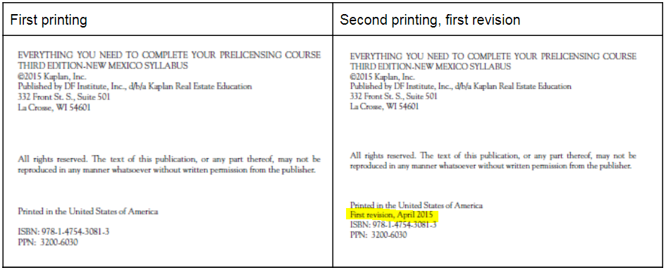

Page/Location | Reads Now | Should Be
235, Figure 8.6 (First deed of trust) | Loan Amount  Less than $30,000  $30,000 or more | Loan Amount  Less than $30,000
235, Figure 8.6 (Second deed of trust) | Loan Amount  Less than $20,000  $20,000 or more | Loan Amount  Less than $20,000
235, Figure 8.7 |  | DELETED Entire Loan Amount column
235, Figure 8.7 (Maximum Costs and Expenses) | Actual costs or $390, whichever is less  Actual costs or 5% of loan amount, whichever is less  Actual costs, but not more than $700 | Actual costs or $390, whichever is more  Not to exceed $700 or actual costs, whichever is less
319, FOR EXAMPLE | Tax $9,656.35  Installment $4,823.17  Delinquent payment $5,305.49 | Tax $9,586.35  Installment $4,793.18  Delinquent payment $5,272.50

