Errata

At Dearborn™ Real Estate Education, we are proud of our reputation for providing the most complete, current, and accurate information in all our products. We are committed to ensuring the kind of quality you rely on. Please note the following changes, which will be reflected in the next printing of Study Guide for Modern Real Estate Practice, 21st Edition.

To use this document, you will need to know which revision of the book you have. The revision is indicated on the copyright page, which is on the second page of the book.

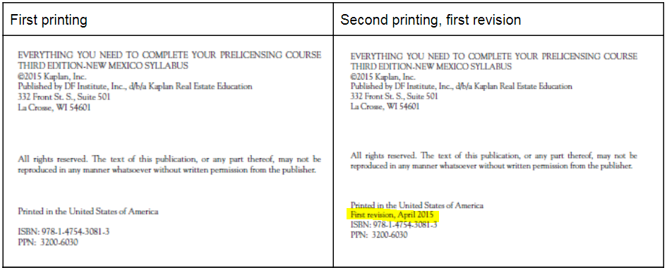

1st revision, 2nd printing
Page/Location | Reads Now | Should Be
26, matching A answer key | - I  - C  - A  - J  - D  - E  - G  - H  - F  - B | 1. J  2. D  3. A  4. B  5. E  6. F  7. H  8. I  9. G  10. C
26, matching B answer key | - I  - G  - J  - E  - D  - H  - A  - F  - C  - B | 1. J  2. H  3. B  4. F  5. E  6. I  7. A  8. G  9. D  10. C
107 (multiple choice answer key) | C. The answer is an offer to purchase. Because an offer to purchase may not be accepted, it would not terminate the listing agreement. (162–163) | C. The answer is the seller refuses to sell. A listing agreement can't be terminated just to suit the broker's convenience. (162–163)

