Errata

At Dearborn™ Real Estate Education, we are proud of our reputation for providing the most complete, current, and accurate information in all our products. We are committed to ensuring the kind of quality you rely on. Please note the following changes, which will be reflected in the next printing of Modern Real Estate Practice Workbook.

To use this document, you will need to know which revision of the book you have. The revision is indicated on the copyright page, which is on the second page of the book.

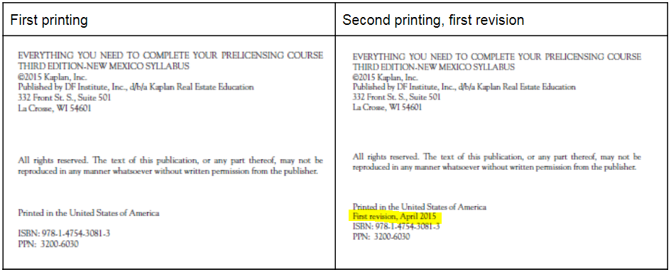

Page/Location | Reads Now | Should Be
13, Question 1 | B. Two years | B. Three years
15, Broker-Level Question 1 | The answer is two years. The couple must occupy the home two out of the last five years, so they may rent it for two years and then sell without paying gains. If they rent it for longer, then they would have to return to living in the home as a primary residence to meet the occupancy requirement. | The answer is three years. The couple must occupy the home two out of the last five years, so they may rent it for three years and then sell without paying gains. If they rent it for longer, then they would have to return to living in the home as a primary residence to meet the occupancy requirement.
143 | 4 b) Making a claim that anyone would construe as literally true, known as _________ (puffing), is not misrepresentation | 4 b) Making a claim that anyone would construe as not literally true, known as _________ (puffing), is not misrepresentation

