Errata

At Dearborn™ Real Estate Education, we are proud of our reputation for providing the most complete, current, and accurate information in all our products. We are committed to ensuring the kind of quality you rely on. Please note the following changes, which will be reflected in the next printing of Tennessee Real Estate Exam Prep Workbook, First Edition.

To use this document, you will need to know which revision of the book you have. The revision is indicated on the copyright page, which is on the second page of the book.

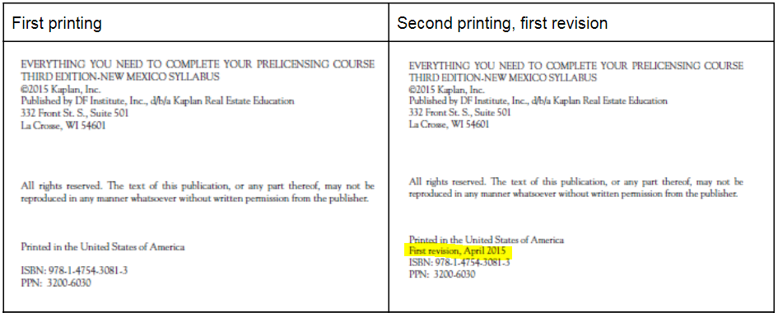

Page/Location | Reads Now | Should Be
7 | (1) Currently the broker application fee is $110 for initial licensure and $80 for license renewal every two years. | (1) Currently the broker application fee is $91 for initial licensure and $75 for license renewal every two years.
8 | (1) Currently the initial application fee is $110 for initial licensure and $80 for license renewal every two years. | (1) Currently the initial application fee is $91 for initial licensure and $75 for license  renewal every two years.
8 | a) The initial license fee for a time-share salesperson is $110 and $100 for an acquisition agent. | a) The initial license fee for a time-share salesperson is $91 and $90 for an acquisition agent.

