Errata

At Dearborn™ Real Estate Education, we are proud of our reputation for providing the most complete, current, and accurate information in all our products. We are committed to ensuring the kind of quality you rely on. Please note the following changes, which will be reflected in the next printing of Essentials of Real Estate Investment 12th Edition.

To use this document, you will need to know which revision of the book you have. The revision is indicated on the copyright page, which is on the second page of the book.

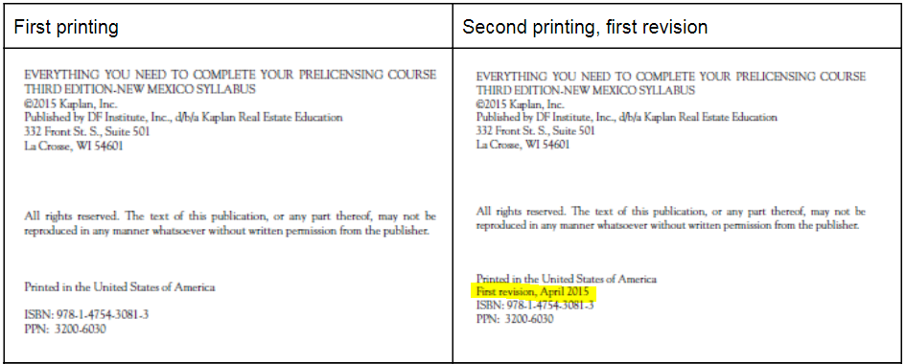

Page/Location | Reads Now | Should Be
93 |  | Add margin note: A property with an NPV of 0 is one, for which the value of the future revenues is exactly equal to the current acquisition costs, using the described discount rate. In other words, the property is being purchased for exactly its appraised value, or as nearly as can be in an imperfect world. This acquisition is easily financed with traditional methods.

