Errata

At Dearborn™ Real Estate Education, we are proud of our reputation for providing the most complete, current, and accurate information in all our products. We are committed to ensuring the kind of quality you rely on. Please note the following changes, which will be reflected in the next printing of California Real Estate Escrow & Title, Second Edition.

To use this document, you will need to know which revision of the book you have. The revision is indicated on the copyright page, which is on the second page of the book.

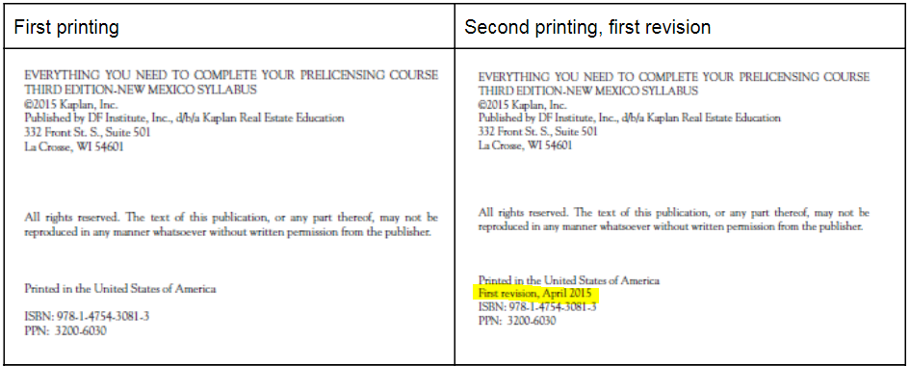

Page/Location | Reads Now | Should Be
Viii | With homeownership rates in the United States reaching 6.2% in 2019 (down from its all-time high of nearly 70% in 2004) | With homeownership rates in the United States reaching 64.2% in 2019 (down from its all-time high of nearly 70% in 2004)

REPRINT
Page/Location | Reads Now | Should Be
Pg. 129 | Two weeks into the escrow, the escrow officer handling the transaction while reviewing the contract between the buyer and the seller—(the California Association of REALTORS® Residential Income Purchase Agreement and Joint Escrow Instructions (RIPA))—noted the omission in paragraph 14 of the “number of legally approved units.” | Two weeks into the escrow, the escrow officer handling the transaction while reviewing the contract between the buyer and the seller—(the California Association of REALTORS® Residential Income Purchase Agreement and Joint Escrow Instructions (RIPA))—noted the omission in the then current contract.
Pg. 194-195 |  | Updated Sample Preliminary Change of Ownership Report form
Pg. 201 | A fee may be charged. The equity protected is established by statute, essentially $75,000 for a single person; $100,000 if the debtor is married or the head of the family; or $175,000 if the debtor is at least 65 years old, is mentally or physically disabled, or is over 55 years old with an income of less than $15,000 per year ($20,000 annually if married). | A fee may be charged by the escrow holder for its assistance.  The equity protected is established by statute, revised by the legislature and approved by the governor, effective January 1, 2021, as follows: (“California Homestead Act, CCP Section 704.730:  (a) The amount of the homestead exemption is the greater of the following:  (1) The countywide median sale price for a single-family home in the calendar year prior to the calendar year in which the judgment debtor claims the exemption, not to exceed six hundred thousand dollars ($600,000).  (2) Three hundred thousand dollars ($300,000).  (b) The amounts specified in this section shall adjust annually for inflation, beginning on January 1, 2022, based on the change in the annual California Consumer Price Index for All Urban Consumers for the prior fiscal year, published by the Department of Industrial Relations.”)
Pg. 299 | Current FHA limits allow a maximum loan based on 115% of the average housing cost of each MSA, up to a maximum of 150% of the base conforming loan limit, which presently equals $726,525. In areas where 115% of the average housing cost is equal to or less than the base conforming loan amount, the maximum loan is 65% of the base conforming loan amount, or $314,827 (65% of $484,350). Remember, these loan amounts (2019 limits) may change annually. | Current FHA limits allow a maximum loan for “high cost” areas such as much of California, based on 115% of the average housing cost of each MSA (usually a county), up to a maximum of 150% of the base conforming loan limits, presently $726,200 which equals $1,089,300. In areas where 115% of the average housing cost is equal to or less than the base conforming loan amount, the maximum loan is 65% of the base conforming loan amount, or $472,0309 (65% of $726,200). Remember, these loan amounts (2023 limits) may change annually.
Pg. 301 | Loan terms greater than 15 years  Loans $726,525 and less and LTV 95% or less: 1.30%  Loans $726,525 and less and LTV greater than 95%: 1.35%  Loans over $726,525 and LTV 95% or less: 1.50%  Loans over $726,525 and LTV greater than 95%: 1.55%  Loan terms 15 years or less  Any loan amount with LTV 78% or less: 0.45%  Loans $726,525 and less and LTV 78.01% to 90%: 0.45%  Loans $726,525 and less and LTV greater than 90%: 0.70%  Loans over $726,525 and LTV 78.01% to 90%: 0.70%  Loans over $726,525 and LTV greater than 90%: 0.95% | Loan terms greater than 15 years  Loans $726,200 and less and LTV 95% or less: .50%  Loans $726,200 and less and LTV greater than 95%: .55%  Loans over $726,200 and LTV 95% or less: .70%  Loans over $726,200 and LTV greater than 95%: .75%  Loan terms 15 years or less  Loans $726,200 and less and LTV 90%: and less .15%  Loans $726,525 and less and LTV greater than 90%: 0..40%  Loans over $726,525 and LTV 78% and less: 0.15%  Loans over $726,525 and LTV over 78% but not greater than 90%: 0.40%  Loans over $726,200 and LTV greater than 90%: .65%
Pg. 303 | Lower rates than FHA and VA, usually 0.25 to 0.50 less for loans up to $484,350; somewhat higher rates for jumbo conforming | Lower rates than FHA and VA, usually 0.25 to 0.50 less for loans up to $726,200; somewhat higher rates are typically required by lenders offering for conforming loans exceeding $726,200.
Pg. 303 | A universal national minimum loan amount exists for all properties located in the continental United States, presently $484,350. Unlike the FHA loan program, the minimum loan amount extends to all states and counties, regardless of the MSA average sales price. Maximum LTVs are as high as 95% of the sales price. | A universal national minimum loan amount (general base limit) exists for all properties located in the continental United States, presently $726,200. Unlike the FHA loan program, the minimum loan amount extends to all states and counties, regardless of the MSA average sales price. Maximum LTVs are as high as 97% of the sales price, with some programs actually allowing 100% to 105% LTVs.
Pg. 303 | A high-cost maximum loan limit up to $726,525 exists for properties located in states having average sales prices that would result in a loan exceeding the base loan limit of $484,350. | A high-cost maximum loan limit up to $1,089,300 (based on 115% of the MSA’s median sales price, but not to exceed 150% of the general base limit)exists for properties located in states having average sales prices that would result in a loan exceeding the base loan limit of $726,200.
Pg. 303 | Seller contributions toward the buyers’ closing costs are limited to the following: | Seller contributions toward the buyers’ closing costs are limited by Fannie Mae and Freddie Mac to the following, but may be further limited by an originating lender:
Pg. 304 | The VA offers up to 100% financing and up to an amount based on four times the veteran’s entitlement, presently $121,087. The VA automatically increases the veteran’s eligibility to one-fourth the conforming loan amount when it is established each year. This means the maximum no-down VA loan is the same as the maximum conforming loan, currently $484,350 (as of 2019). | The VA offers up to 100% financing with no maximum loan amount as of January 1, 2021 for veterans using the VA loan program for the first time. The originating lender sets the maximum loan amount based on its own underwriting standards. The VA program utilizes what is referred to as a veteran’s “entitlement” in determining maximum “no-down” loan amounts for veterans having obtained a prior VA loan. The “no-down” loan is equal to four times the veteran’s remaining “unrestored” entitlement. The current full entitlement is $181,550 (four times the GSE general base loan limit). The VA automatically increases the veteran’s eligibility to one-fourth the conforming loan amount, less any unrestored entitlement, when it is established each year.
Pg. 304 | Veterans using the program for the first time pay a 2.15% funding fee (indemnity fee) when no down payment is made, 1.5% for a 5% down payment, and 1.25% for a 10% down payment. The fee may be added to the loan, providing the total does not exceed the maximum allowed. | Veterans using the program for the first time pay a 2.3% funding fee (indemnity fee) when no down payment is made, 1.65% for a 5% down payment, and 1.40% for a 10% down payment. The fee may be added to the loan, providing the total does not exceed the maximum allowed.
Pg. 304 | A disabled veteran pays no funding fee. | Purple Heart recipients pay no funding fee.
Pg. 304 | Veterans with no down payment using the program a subsequent time pay a 3.3% funding fee. | Veterans with no down payment using the program a subsequent time pay a 3.6% funding fee.

