**Errata**

At Dearborn™ Real Estate Education, we are proud of our reputation for providing the most complete, current, and accurate information in all our products. We are committed to ensuring the kind of quality you rely on. Please note the following changes, which will be reflected in the next printing of *Modern Real Estate Practice in New York for Salespersons 14E*.

To use this document, you will need to know which revision of the book you have. The revision is indicated on the copyright page, which is on the second page of the book.

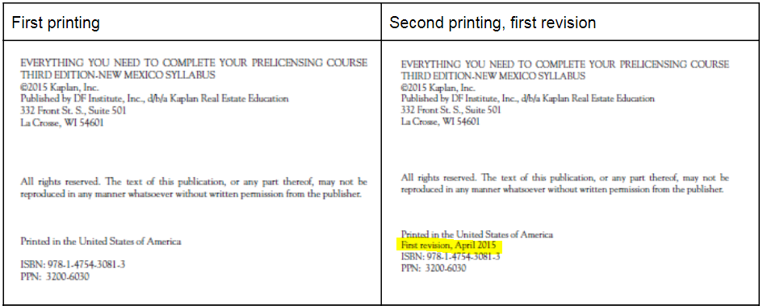

|  |  |  |
| --- | --- | --- |
| **Page/Location** | **Reads Now** | **Should Be** |
| Vii, Special Acknowledgment | Her contributions  are still evident in this thirteenth edition, | Her contributions  are still evident in this fourteenth edition, a |
| P400, Figure 17.1 | The chart said that only NY City has as protected classes has as protected classes alienage/citizenship, lawful source of income and survivors of domestic violence, sex offenses and stalking. | The chart should be updated so that the word “Yes” is under Lawful source of income, Citizenship, and Survivors of domestic violence. |