Errata

At Dearborn™ Real Estate Education, we are proud of our reputation for providing the most complete, current, and accurate information in all our products. We are committed to ensuring the kind of quality you rely on. Please note the following changes, which will be reflected in the next printing of Modern Real Estate Practice, 21st Edition.

To use this document, you will need to know which revision of the book you have. The revision is indicated on the copyright page, which is on the second page of the book.

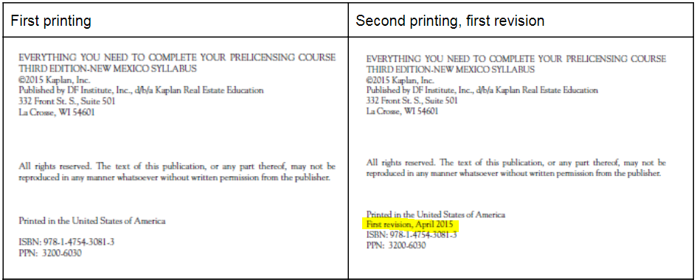

1st revision, 2nd printing
Page/Location | Reads Now | Should Be
19 |  | Duplicated paragraphs on factory-built housing under “Real property vs. personal property” removed
34, Figure 3.1, 1st box 2nd row | “Fee Simple Determinable” | “Fee Simple Absolute”
34, Figure 3.1, 1st box 3rd row | “Special Limitation with Possibility of Reverter” | “Fee Simple Determinable”
179-181 | Figure 10.2: Sample Listing Agreement (Continued) | Figure 10.3: Sample Buyer Representation Agreement (Continued)
257, item 7 | “…if they include mortgage financing terms??” | “…if they include mortgage financing terms?”
439, Appendix | Florida State website is:  www.stateofflorida.com/real -estate/ | https://www.myfloridalicense.com
513, emblements page reference | 20 | 19
559, Item 28 | C 78,459 | A 72,455
561, Figure 2.3 page reference | 23 | 22
561 | FIGURE 3.1: Fee Simple Estate | FIGURE 3.1: Fee Simple Estates
561 | FIGURE 3.2: Life Estate | FIGURE 3.2: Life Estates
561 | FIGURE 5.2: Map of United States Showing Meridians and Base Lines | FIGURE 5.2: Map of United States Showing Principal Meridians and Base Lines
562 | FIGURE 15.1: Credits and Debits 285 | FIGURE 15.1: Types of Liens 295
562 | FIGURE 18.2: HUD’s Advertising Guidelines | FIGURE 18.2: Acceptable Terminology
562, FIGURE M.1 page reference | 443 | 442
562, FIGURE M.2 page reference | 454 | 453
562, FIGURE M.3 page reference | 466 | 465
565, emblements page references | 28 | 19, 28
565, fixture, legal tests page reference | 29 | 20, 29
566, fructus industrials page reference | 28 | 19, 28

