Errata

At Dearborn™ Real Estate Education, we are proud of our reputation for providing the most complete, current, and accurate information in all our products. We are committed to ensuring the kind of quality you rely on. Please note the following changes, which will be reflected in the next printing of Illinois Required Broker Post-Licensing Applied Brokerage Principles, First Edition.

To use this document, you will need to know which revision of the book you have. The revision is indicated on the copyright page, which is on the second page of the book.

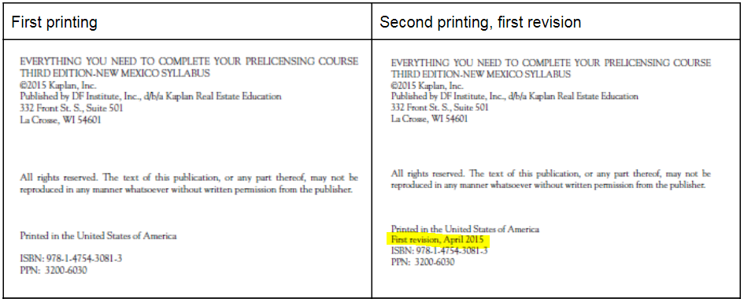

Page/Location | Reads Now | Should Be
p.3/Key Terms |  | Added Designed Managing Broker
p.8/Course Content | Regarding the elective curriculum, the Illinois State Board of Education considers subjects that cover the various aspects of the practice of real estate that are covered under the scope of the Act. | Regarding the elective curriculum, the Illinois Real Estate Administration and Disciplinary Board considers subjects that cover the various aspects of the practice of real estate that are covered under the scope of the Act.
p.9/Course Content | All subject areas must be recommended by the Illinois State Board of Education and then approved by the IDFPR. | All subject areas must be recommended by the Board and then approved by the department.
p.9/Course Content | If a renewal applicant has earned CE hours in another state, the Illinois State Board of Education may approve the credit at its discretion based upon whether the course is one that would be approved under the Act. | If a renewal applicant has earned CE hours in another state, the department may approve the credit at its discretion based upon whether the course is one that would be approved under the Act.
p.32/Escrow | 6. All escrow moneys accepted by a sponsoring/managing broker must be placed in the sponsoring broker’s escrow account not later than the next business day following the transaction. | 6. All escrow moneys accepted by a sponsoring/designated managing broker must be placed in the sponsoring broker’s escrow account not later than the next business day following the transaction.
p. 38/Broker Responsibilities/Accounting | A sponsoring broker may delegate the bookkeeping duties to another person, including a managing broker, bookkeeper, certified public accountant, unlicensed personal assistant, licensed personal assistant, or sponsored licensee. | A sponsoring broker may delegate the bookkeeping duties to another person, including a designated managing broker, bookkeeper, certified public accountant, unlicensed personal assistant, licensed personal assistant, or sponsored licensee.
46/Teams | - are supervised by the same managing broker and sponsored by the same sponsoring broker. 225 ILCS 454 Section 1-10. | - are supervised by the same designated managing broker and sponsored by the same sponsoring broker. 225 ILCS 454 Section 1-10.

