Errata

At Dearborn™ Real Estate Education, we are proud of our reputation for providing the most complete, current, and accurate information in all our products. We are committed to ensuring the kind of quality you rely on. Please note the following changes, which will be reflected in the next printing of Illinois Required Broker Post-Licensing Risk Management/Discipline, First Edition.

To use this document, you will need to know which revision of the book you have. The revision is indicated on the copyright page, which is on the second page of the book.

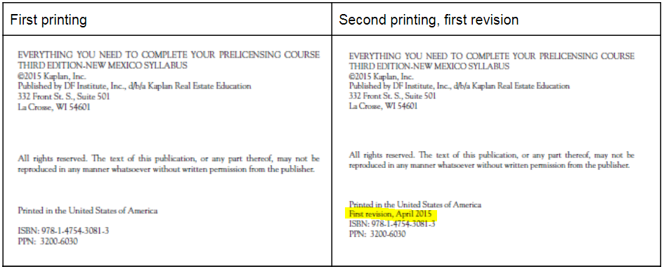

Page/Location | Reads Now | Should Be
p. 20/3rd paragraph | The sponsoring broker must complete a Consent to Examine and Audit Special Accounts form for each account and each financial institution and must file these forms with the Illinois Department of Financial and Professional Regulation. | The sponsoring broker must complete a Consent to Examine and Audit Special Accounts form for each account and each financial institution and must file these forms with the Illinois Department of Financial and Professional Regulation the Division of Real Estate.
p. 20/Sponsored Licensee Responsibility | A sponsoring broker may delegate the bookkeeping duties for escrow accounts to another person, including a managing broker, bookkeeper, certified public accountant, unlicensed personal assistant, licensed personal assistant, or sponsored licensee. | A sponsoring broker may delegate the bookkeeping duties for escrow accounts to another person, including a designated managing broker, bookkeeper, certified public accountant, unlicensed personal assistant, licensed personal assistant, or sponsored licensee.
p. 28/Deposit/Disbursement Requirements | All escrow moneys accepted by a sponsoring/managing broker must be placed in the sponsoring broker’s escrow account not later than the next business day following the transaction. | All escrow moneys accepted by a sponsoring/designated managing broker must be placed in the sponsoring broker’s escrow account not later than the next business day following the transaction.
p. 40/Agency | The sponsoring/managing broker should establish procedures regarding all transactions in which the sponsoring broker represents a party for reviewing every listing, sales agreement, or lease to check whether the forms are properly completed, all legally required riders are attached, and all disclosures, including agency, have been made. | The sponsoring/designated managing broker should establish procedures regarding all transactions in which the sponsoring broker represents a party for reviewing every listing, sales agreement, or lease to check whether the forms are properly completed, all legally required riders are attached, and all disclosures, including agency, have been made.
p. 40/Agency | The managing broker should establish transaction management procedures documented in the policy and procedure manual that provide a step-by-step process for the creation and maintenance of the transaction file. | The designated managing broker should establish transaction management procedures documented in the policy and procedure manual that provide a step-by-step process for the creation and maintenance of the transaction file.
p. 41/Areas of Competency | The sponsoring or managing broker should remind sponsored licensees not to attempt to provide services to consumers that are outside their area of expertise. | The sponsoring or designated managing broker should remind sponsored licensees not to attempt to provide services to consumers that are outside their area of expertise.
p. 42/Team Structure/Operation | Teams are supervised by the same managing broker and sponsored by the same sponsoring broker as all the other licensees in the office. | Teams are supervised by the same designated managing broker and sponsored by the same sponsoring broker as all the other licensees in the office.
p. 43/Written Employment/Independent Contractor Agreements | If the sponsoring broker is an entity, there must be a written agreement between the brokerage entity and the managing broker. | If the sponsoring broker is an entity, there must be a written agreement between the brokerage entity and the designated managing broker.

