**Errata**

At Dearborn™ Real Estate Education, we are proud of our reputation for providing the most complete, current, and accurate information in all our products. We are committed to ensuring the kind of quality you rely on. Please note the following changes, which will be reflected in the next printing of Post-Licensing Education For Florida Real Estate Sales Associates.

To use this document, you will need to know which revision of the book you have. The revision is indicated on the copyright page, which is on the second page of the book.

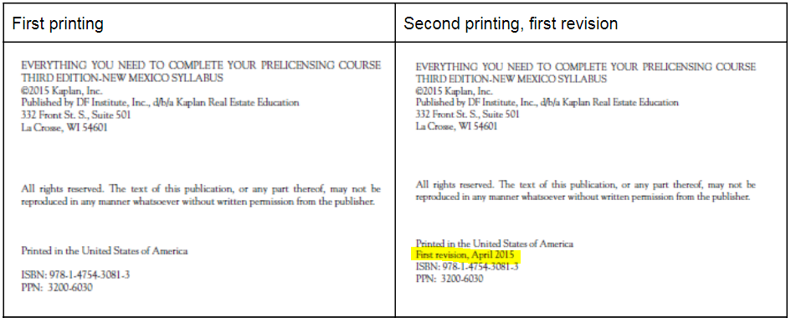

|  |  |  |
| --- | --- | --- |
| **Page/Location** | **Reads Now** | **Should Be** |
| 121, Question #9 | 1. $20,000 2. $28,900 3. $16,300 4. $29,000 | 1. $120,000 2. $128,900 3. $116,300 4. $129,000 |
| 121, Question #10 | 1. $10,900 2. $10,800 3. $11,800 4. $10,100 | 1. $26,900 2. $27,800 3. $28,800 4. $26,100 |
| 121, Question #11 | 1. $1,700 subtracted 2. $2,600 added 3. $1,300 subtracted 4. $900 subtracted | 1. $5,800 subtracted 2. $6,600 added 3. $5,300 subtracted 4. $4,900 subtracted |
| 121, Question #12 | 1. $14,500 2. $16,300 3. $17,100 4. $15,400 | 1. $97,600 2. $99,500 3. $101,100 4. $98,400 |
| 184, Question #4 | He has ~~three~~ days to close… | He has seven days to close… |
| 352, Question #9, last line | …mortgage balance - $28,898.40 seller’s equity; round to $28,900. | …mortgage balance - $128,898.40 seller’s equity; round to $128,900. |
| 352, Question #11, first line | The answer is $5,800 subtracted… | The answer is $2,500 subtracted… |