Errata

At Dearborn™ Real Estate Education, we are proud of our reputation for providing the most complete, current, and accurate information in all our products. We are committed to ensuring the kind of quality you rely on. Please note the following changes, which will be reflected in the next printing of California Real Estate Principles Workbook, Third Edition.

To use this document, you will need to know which revision of the book you have. The revision is indicated on the copyright page, which is on the second page of the book.

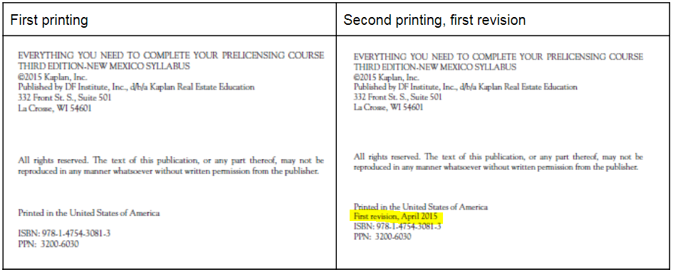
Second printing, first revision
Page/Location | Reads Now | Should Be
37, question 16. | Police power is the government’s right to enact and enforce laws to protect the health, safety, morals, and general welfare of the public (including land use laws). | A qualified fee estate, also sometimes referred to as a defeasible estate, is a form of ownership that can be lost by violating a condition in the deed granting the ownership interest.
63, question 16. | C | D
181, PAGE 3 | personal property | real property
Third printing, second revision
Page/Location | Reads Now | Should Be
63, question 15 | D | C

