Errata

At Dearborn™ Real Estate Education, we are proud of our reputation for providing the most complete, current, and accurate information in all our products. We are committed to ensuring the kind of quality you rely on. Please note the following changes, which will be reflected in the next printing of Arizona Real Estate Principles 1E Revised.

To use this document, you will need to know which revision of the book you have. The revision is indicated on the copyright page, which is on the second page of the book.

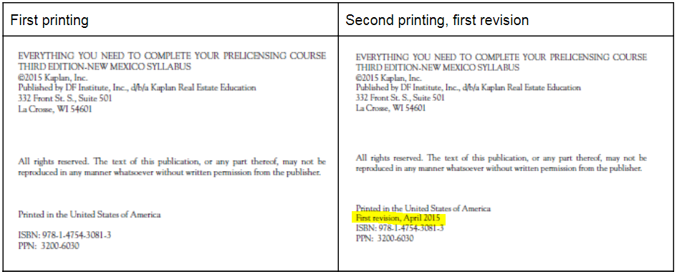

Page/Location | Reads Now | Should Be
Pg 11/Margin note | Doesn’t exist | Added:  Real estate licensees engaged in wholesaling must remember that disclosure of the fact that they hold a real estate license is also required, under Arizona Administrative Code R4-28-1101(E). Specifically, a real estate salesperson or broker shall not act directly or indirectly in a transaction without informing the other parties in the transaction, in writing and before the parties of a present or prospective interest or conflict in the transaction, including that the, (1)salesperson or broker has a license and is acting as a principal.

