Errata

At Dearborn™ Real Estate Education, we are proud of our reputation for providing the most complete, current, and accurate information in all our products. We are committed to ensuring the kind of quality you rely on. Please note the following changes, which will be reflected in the next printing of California Legal Aspects of Real Estate, 11th Edition.

To use this document, you will need to know which revision of the book you have. The revision is indicated on the copyright page, which is on the second page of the book.

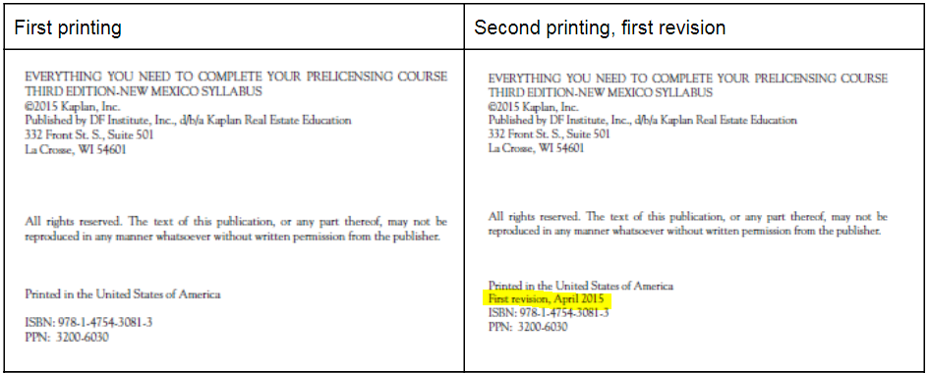

Page/Location | Reads Now | Should Be
575 | Interstate Land Sales Full Disclosure Act A disclosure act for subdivisions of 25 or more unimproved residential lots offered for sale in interstate commerce. | Interstate Land Sales Full Disclosure Act A disclosure act for subdivisions of 100 or more unimproved residential lots offered for sale in interstate commerce.
52, Question #8 | A selling agent can represent | A selling agent CANNOT represent
557, Unit 2, Question #8 | 8. D | 8. A

