Errata

At Dearborn™ Real Estate Education, we are proud of our reputation for providing the most complete, current, and accurate information in all our products. We are committed to ensuring the kind of quality you rely on. Please note the following changes, which will be reflected in the next printing of Modern Real Estate Practice in Texas, 18th Edition.

To use this document, you will need to know which revision of the book you have. The revision is indicated on the copyright page, which is on the second page of the book.

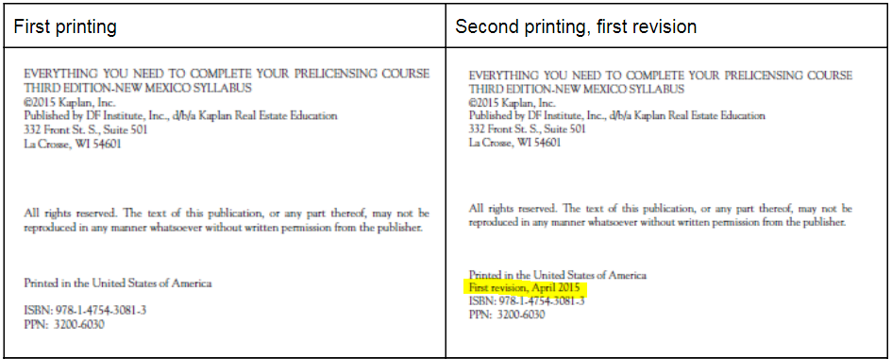

Page/Location | Reads Now | Should Be
ix, seventh bullet | detailed rationales for the answers to end-of-unit review questions; rationales are available exclusively online at www .dearborn .com through the Instructor Resource Guides link. | [Delete]
6 | The first law to regulate real estate brokerage in Texas, the Texas Real Estate Dealers Act, was passed in 1939. The law that currently regulates real estate in Texas is the Texas Real Estate License Act (License Act), passed by the Texas Legislature in 1949. The act has been revised many times, most recently in 2017, and is administered by the Texas Real Estate Commission. | e agents in Texas were first licensed through the Securities Division of the Secretary of State's office, beginning in 1939 with passage of the Real Estate Dealers License Act (House Bill 17, 46th Legislature, Regular Session).  In 1949, the Texas Legislature established the Texas Real Estate Commission (TREC). The commission administers the act (Senate Bill 28, 51st Legislature, Regular Session). The act has been revised many times, most recently in 2015.  The act’s name was changed to the Texas Real Estate License Act (TRELA) in 1955. The purpose of TRELA is to protect the public through regulation of real estate license holders, real estate inspectors, residential service companies, and entities offering timeshare interests.
13, no image displayed | Some of the major factors include the labor force, construction costs, and government controls and financial policies (see Figure 1.6). | [Image displayed below, Figure 1.6]

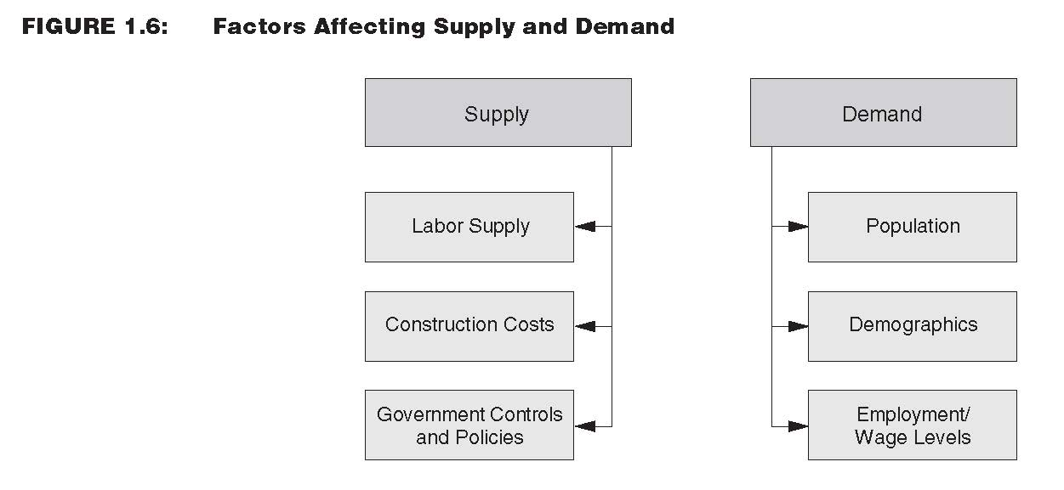

350, T-Bar at top of page. | $185,250 net after commission (part)  ---------------------------------  Total = ? | 95% = 0.95 rate  | after commission | $123,200 sales price (part)  ---------------------------------  Original cost | 110% = 1.10 (total) = ? | (rate)
432, United States Mortgage Law | After gaining independence from England, the original 13 colonies adopted the English laws as their basic body of law. From their inception, American courts of equity considered a mortgage a voluntary lien on real estate, given to secure the payment of a debt or the performance of an obligation. Those states that interpret a mortgage purely as a lien on real property are called lien theory states. In such states, if a mortgagor defaults, the lender is required to foreclose the lien, offer the property for sale, and apply the funds received from the sale to reduce or extinguish the obligation. The owner, not the lender, has a right to rental income while property is posted for foreclosure.  Other states, including Texas, recognize a lender as the owner of mortgaged land. This ownership is subject to defeat on full payment of the debt or performance of the obligation. These states are called title theory states. Under title theory, a lender has the right to possession of and rents from the mortgaged property on default by the borrower. | After gaining independence from England, the original 13 colonies adopted the English laws as their basic body of law. From their inception, American courts of equity considered a mortgage a voluntary lien on real estate, given to secure the payment of a debt or the performance of an obligation. Those states, including Texas, that interpret a mortgage purely as a lien on real property are called lien theory states. In such states, if a mortgagor defaults, the lender is required to foreclose the lien, offer the property for sale, and apply the funds received from the sale to reduce or extinguish the obligation. The owner, not the lender, has a right to rental income while property is posted for foreclosure. Although many lien theory states allow a statutory redemption period, Texas law contains no provision for redemption of owner-occupied property foreclosed under a deed of trust.  Other states recognize a lender as the owner of mortgaged land. This ownership is subject to defeat on full payment of the debt or performance of the obligation. These states are called title theory states. Under title theory, a lender has the right to possession of and rents from the mortgaged property on default by the borrower.
439 | Because Texas is a title theory state, the lender (rather than the borrower) is considered the owner of the property. | Because Texas is a lien theory state, the borrower (rather than the lender) is considered the owner of the property.
457 | Texas is a title theory state. | Texas is a lien theory state.
625 | To be eligible to file an application for a sales agent license, an individual must be a citizen of the United States, or a lawfully admitted alien, eighteen (18) years of age or older, and a legal resident of Texas or a legal resident of a municipality whose boundary is contiguous at any point with the boundary of a municipality in Texas. | To be eligible to file an application for a sales agent license, an individual must be a citizen of the United States, or a lawfully admitted alien, and eighteen (18) years of age or older.
663, Glossary, lien theory | Texas is a title theory state. | Texas is a lien theory state.

