Errata

At Dearborn™ Real Estate Education, we are proud of our reputation for providing the most complete, current, and accurate information in all our products. We are committed to ensuring the kind of quality you rely on. Please note the following changes, which will be reflected in the next printing of California Real Estate Practice Eleventh Edition.

To use this document, you will need to know which revision of the book you have. The revision is indicated on the copyright page, which is on the second page of the book.

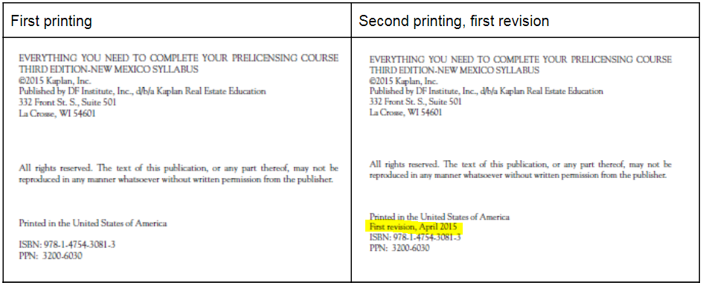

Page/Location | Reads Now | Should Be
Pg. 489, Federal Gift Tax |  | New paragraph:  It is possible to exceed the $16,000 limit because there is a lifetime gift tax exclusion for donors. The exclusion for 2022 was set at $12.06 million for a lifetime total of $24.12 million.  Note: the lifetime exclusion is scheduled to be reduced. By 2026, it is to be set at $6 million.  For the years where gifts exceed the annual exclusion amount, you must file IRS Form 709 (United States Gift and Generation Skipping Transfer). Failure to file will result in penalties.

