**Errata**

At Dearborn™ Real Estate Education, we are proud of our reputation for providing the most complete, current, and accurate information in all our products. We are committed to ensuring the kind of quality you rely on. Please note the following changes, which will be reflected in the next printing of *Modern Real Estate Practice in Texas, 18th Edition*.

This document contains a running list of revisions made since the text was first printed. Depending on what printing of the book you have, these revisions may or may not be included.

|  |  |  |
| --- | --- | --- |
| **Page/Location** | **Reads Now** | **Should Be** |
| ix, seventh bullet | detailed rationales for the answers to end-of-unit review questions; rationales are available exclusively online at www .dearborn .com through the Instructor Resource Guides link. | [Delete] |
| 6 | In 1949, the Texas Legislature established the **Texas Real Estate Commission (TREC)**. The commission administers the act (Senate Bill 28, 51st Legislature, Regular Session). The act has been revised many times, most recently in 2015.  Commission. | In 1949, the Texas Legislature established the **Texas Real Estate Commission (TREC)**. The commission administers the act (Senate Bill 28, 51st Legislature, Regular Session). |
| 13, no image displayed | Some of the major factors include the labor force, construction costs, and government controls and financial policies (see Figure 1.6). | [Image displayed below, Figure 1.6] |
|  |  |  |

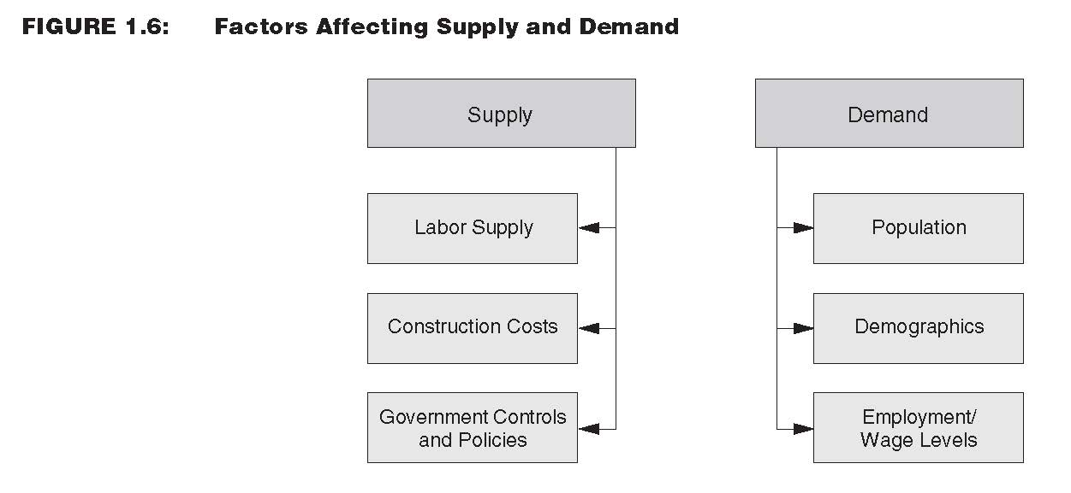

|  |  |  |
| --- | --- | --- |
| 106 | On July 1, 2010, HUD announced a policy that provides LGBT individuals and families with further assistance when facing housing discrimination. Although the Fair Housing Act does not explicitly prohibit housing discrimination based on sexual orientation or gender identity, according to HUD, the “guidance treats gender identity discrimination as gender discrimination under the Fair Housing Act, and instructs HUD staff to inform individuals filing complaints about state and local agencies that have LGBT-inclusive discrimination laws.” Approximately 19 states and the District of Columbia, as well as more than 200 cities, towns, and counties, have additional protections that prohibit discrimination against LGBT individuals.  The HUD press release provides examples of situations that may be jurisdictional under the Fair Housing Act. These examples are as follows:   * “If a man alleges that he is being evicted because he is gay and his landlord believes he will infect other tenants with HIV, then the allegation of discrimination may be jurisdictional under the Fair Housing Act based on disability, because the man is regarded as having a disability, HIV/AIDS.” * “Similarly, if a female prospective tenant is alleging discrimination by a landlord because she wears masculine clothes and engages in other physical expressions that are stereotypical male, then the allegations may be jurisdictional under the act as discrimination based on gender.” | In *Bostock v. Clayton County*, 140 S. Ct. 1731 (2020), the Supreme Court held that Title VII, which prohibits employment discrimination based on race, color, religion, sex and national origin, prohibits discrimination on the basis of sexual orientation and gender identity. In January 2021, President Biden issued an executive order directing federal agencies to amend existing policies and regulation to prevent discrimination on the basis of gender identity and sexual orientation consistent with the Supreme Court’s decision in *Bostock v. Clayton County*. Pursuant to the executive order, HUD issued a memorandum in February 2021 implementing the executive order, stating that HUD will “accept for filing and investigate all complaints of sex discrimination, including discrimination because of gender identity or sexual orientation, that meet other jurisdictional requirements. |
| 226 | The licensing of both home inspectors and residential service companies is regulated by TREC. The applicable laws and rules, along with the Property Inspection Report and a list of residential service company license holders, are available on the TREC website: www .trec .texas .gov. | The applicable laws and rules, along with the Property Inspection Report and a list of residential service company license holders, are available on the TREC website: www .trec .texas .gov. |
| 350, T-Bar at top of page. | $185,250 net after commission (part)  ---------------------------------  Total = ? | 95% = 0.95 rate  | after commission | $123,200 sales price (part)  ---------------------------------  Original cost | 110% = 1.10 (total) = ? | (rate) |
| 432, United States Mortgage Law | After gaining independence from England, the original 13 colonies adopted the English laws as their basic body of law. From their inception, American courts of equity considered a mortgage a voluntary lien on real estate, given to secure the payment of a debt or the performance of an obligation. Those states that interpret a mortgage purely as a lien on real property are called **lien theory** states. In such states, if a mortgagor defaults, the lender is required to foreclose the lien, offer the property for sale, and apply the funds received from the sale to reduce or extinguish the obligation. The owner, not the lender, has a right to rental income while property is posted for foreclosure.  Other states, including Texas, recognize a lender as the owner of mortgaged land. This ownership is subject to defeat on full payment of the debt or performance of the obligation. These states are called **title theory** states. Under title theory, a lender has the right to possession of and rents from the mortgaged property on default by the borrower. | After gaining independence from England, the original 13 colonies adopted the English laws as their basic body of law. From their inception, American courts of equity considered a mortgage a voluntary lien on real estate, given to secure the payment of a debt or the performance of an obligation. Those states, including Texas, that interpret a mortgage purely as a lien on real property are called **lien theory** states. In such states, if a mortgagor defaults, the lender is required to foreclose the lien, offer the property for sale, and apply the funds received from the sale to reduce or extinguish the obligation. The owner, not the lender, has a right to rental income while property is posted for foreclosure. Although many lien theory states allow a statutory redemption period, Texas law contains no provision for redemption of owner-occupied property foreclosed under a deed of trust.  Other states recognize a lender as the owner of mortgaged land. This ownership is subject to defeat on full payment of the debt or performance of the obligation. These states are called **title theory** states. Under title theory, a lender has the right to possession of and rents from the mortgaged property on default by the borrower. |
| 439 | Because Texas is a title theory state, the lender (rather than the borrower) is considered the owner of the property. | Because Texas is a lien theory state, the borrower (rather than the lender) is considered the owner of the property. |
| 457 | Texas is a title theory state. | Texas is a lien theory state. |
| 625 | To be eligible to file an application for a sales agent license, an individual must be a citizen of the United States, or a lawfully admitted alien, eighteen (18) years of age or older, and a legal resident of Texas or a legal resident of a municipality whose boundary is contiguous at any point with the boundary of a municipality in Texas. | To be eligible to file an application for a sales agent license, an individual must be a citizen of the United States, or a lawfully admitted alien, and eighteen (18) years of age or older. |
| 663, Glossary, lien theory | Texas is a title theory state. | Texas is a lien theory state. |