Errata

At Dearborn™ Real Estate Education, we are proud of our reputation for providing the most complete, current, and accurate information in all our products. We are committed to ensuring the kind of quality you rely on. Please note the following changes, which will be reflected in the next printing of Florida Real Estate Exam Manual for Sales Associates and Brokers, 43rd Edition

To use this document, you will need to know which revision of the book you have. The revision is indicated on the copyright page, which is on the second page of the book.

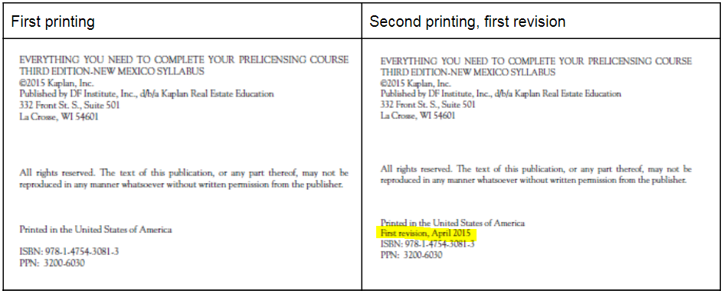

Page/Location | Reads Now | Should Be
93, EXAMPLE | 80 acres ÷ 40 acres = 120 acres | 80 acres + 40 acres = 120 acres
93, EXAMPLE,  Alternative Solution | 80 acres ÷ 40 acres = 120 acres | 80 acres + 40 acres = 120 acres
187, question 438 | A homesteaded property is located in Orange County, Florida. The city tax rate is 8.3 mills, the county tax rate is 8.9 mills, and the school district tax rate is 6.2 mills. The homeowner is a widower and has qualified for homestead exemptions. The home has been assessed at $192,900. What are the property taxes due? | A homesteaded property is located in Orange County, Florida. The city tax rate is 8.2 mills, the county tax rate is 8.9 mills, and the school district tax rate is 6.2 mills. The homeowner is a widower and has qualified for homestead exemptions. The home has been assessed at $192,900. What are the property taxes due?
203, question 562 | C. Credit to the seller and a debit to the buyer, page 3 of the Closing Disclosure | C. Credit to the seller and a debit to the buyer, page 2 of the Closing Disclosure
205 | Use the following information to answer problems 574-584: | Use the following information to answer problems 575-585:

