Errata

At Dearborn™ Real Estate Education, we are proud of our reputation for providing the most complete, current, and accurate information in all our products. We are committed to ensuring the kind of quality you rely on. Please note the following changes, which will be reflected in the next printing of California Real Estate Broker Drill and Practice, Second Edition.

To use this document, you will need to know which revision of the book you have. The revision is indicated on the copyright page, which is on the second page of the book.

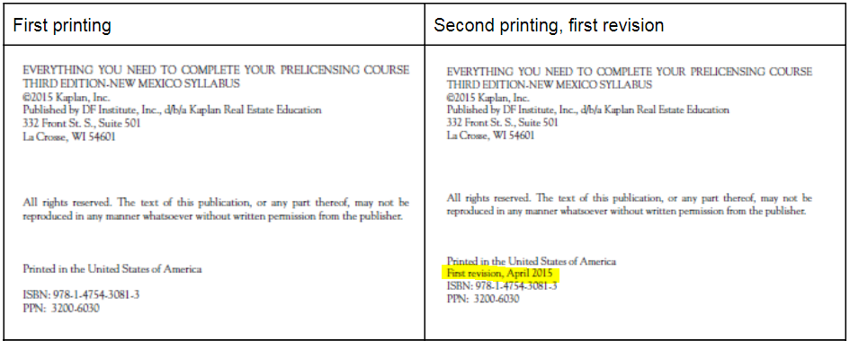

Page/Location | Reads Now | Should Be
107, question 23 | A broker who negotiates a real estate loan to which the Brokers Loan Law is applicable must deliver the mortgage loan disclosure statement to the borrower  a. within 24 hours.  b. three days previous to signing.  c. after close of escrow.  d. at signing. | A broker negotiates a real estate loan to which the Brokers Loan Law is applicable and also receives a loan application from a borrower. The broker must deliver the mortgage loan disclosure statement to the borrower  a. within 24 hours.  b. at the time the loan application is received.  c. after close of escrow.  d. within three business days of receiving the completed, written loan application.
253, question 23 | D A Mortgage Loan  Disclosure Statement must  be presented, and the borrower’s  signature obtained,  before the borrower  becomes obligated. | D The broker must deliver the mortgage loan disclosure statement within three business days of receiving a completed, written loan application or before the borrower is obligated to take the loan, whichever is earlier. Normally a borrower is obligated to take a loan when they sign a promissory note, which typically takes place at close of escrow. A broker receiving a loan application typically occurs earlier in the process and therefore establishes the requirement to deliver the mortgage loan disclosure statement within three business days to the borrower.

