Errata

At Dearborn™ Real Estate Education, we are proud of our reputation for providing the most complete, current, and accurate information in all our products. We are committed to ensuring the kind of quality you rely on. Please note the following changes, which will be reflected in the next printing of Guide to Passing the Pearson VUE Real Estate Exam, Tenth Edition.

To use this document, you will need to know which revision of the book you have. The revision is indicated on the copyright page, which is on the second page of the book.

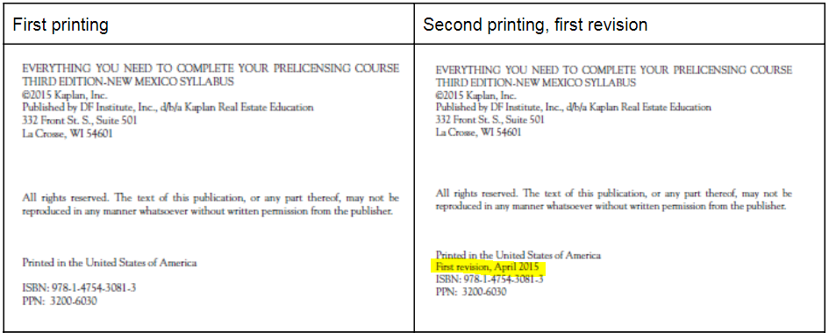

Page/Location | Reads Now | Should Be
294, question 59. | B Cost plus improvements less depreciation. (67) | D Book value is the original property cost plus the cost of any improvements, minus any depreciation taken. (67)
296, question 47. | A What is left after all expenses. (115) | B The cash flow is net spendable income. It is what is left after all expenses are paid. Depreciation is not a cash expense so is not deducted. (115)

First Revision
Page/Location | Reads Now | Should Be
20, 17. | The maximum number of complete townships possible within a ranch that is 26 square miles is  A. 4.  B. 6.  C. 16.  D. 18. | The maximum number of complete townships possible within a ranch that is 26 miles square is  A. 4.  B. 6.  C. 16.  D. 18.

