Errata

At Dearborn™ Real Estate Education, we are proud of our reputation for providing the most complete, current, and accurate information in all our products. We are committed to ensuring the kind of quality you rely on. Please note the following changes, which will be reflected in the next printing of California Real Estate Principles 11th Edition.

To use this document, you will need to know which revision of the book you have. The revision is indicated on the copyright page, which is on the second page of the book.

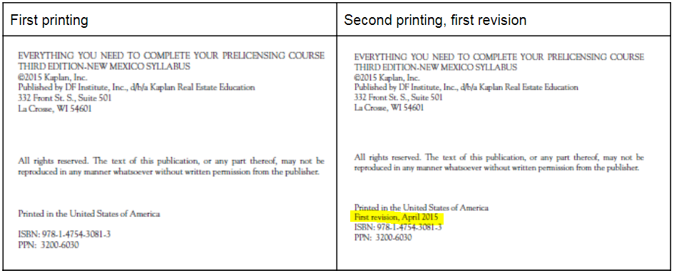

First Revision
Page/Location | Reads Now | Should Be
235, Figure 8.6 (First deed of trust) | Loan Amount  Less than $30,000  $30,000 or more | Loan Amount  Less than $30,000
235, Figure 8.6 (Second deed of trust) | Loan Amount  Less than $20,000  $20,000 or more | Loan Amount  Less than $20,000
235, Figure 8.7 |  | DELETED Entire Loan Amount column
235, Figure 8.7 (Maximum Costs and Expenses) | Actual costs or $390, whichever is less  Actual costs or 5% of loan amount, whichever is less  Actual costs, but not more than $700 | Actual costs or $390, whichever is more  Not to exceed $700 or actual costs, whichever is less
319, FOR EXAMPLE | Tax $9,656.35  Installment $4,823.17  Delinquent payment $5,305.49 | Tax $9,586.35  Installment $4,793.18  Delinquent payment $5,272.50

Second Revision
Page/Location | Reads Now | Should Be
22, License Conduct | www.dre.ca.gov/files/pdf/refbook/ref00.pdf | www.dre.ca.gov/publications/ReferenceBook.html
316 | "The county assessor is the elected official responsible for determining assessed values and preparing the tax roll. Anyone who acquires an interest in real property must file a change in ownership statement with the county recorder or assessor within 45 days of the date the transfer is recorded. If the transfer is not recorded, the statement must be filed within 45 days of the date of the change in ownership. The penalty for failure to file within 45 days of a written request by the assessor is $100 or 10% of the tax computed on the new base property value, whichever is greater. The penalty also applies if complete information is not supplied following a second request. " | "The county assessor is the elected official responsible for determining assessed values and preparing the tax roll. Anyone who acquires an interest in real property must file a change in ownership statement with the county recorder or assessor within 90 days of the date the transfer is recorded. If the transfer is not recorded, the statement must be filed within 90 days of the date of the change in ownership. The penalty for failure to file within 90 days of a written request by the assessor is $100 or 10% of the tax computed on the new base property value, whichever is greater. The penalty also applies if complete information is not supplied following a second request. "

