Errata

At Dearborn™ Real Estate Education, we are proud of our reputation for providing the most complete, current, and accurate information in all our products. We are committed to ensuring the kind of quality you rely on. Please note the following changes, which will be reflected in the next printing of Essentials of New Jersey Real Estate, Fourteenth Edition.

To use this document, you will need to know which revision of the book you have. The revision is indicated on the copyright page, which is on the second page of the book.

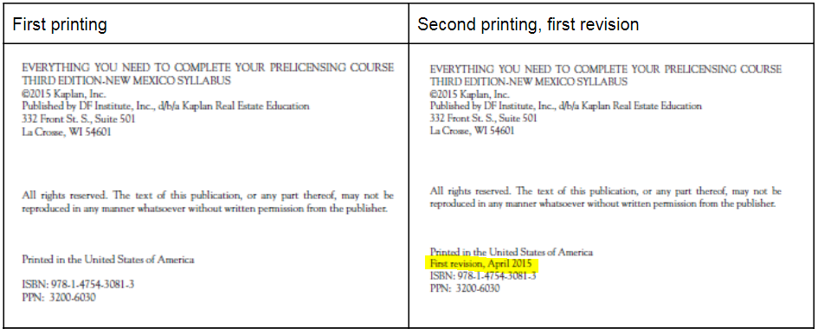

Page/Location | Reads Now | Should Be
21-22/Probation, Suspension, and Revocation | The commission may investigate complaints against the action of licensees or investigate on its own. It may  - place a licensee on probation;  - suspend a license (suspension); or  - revoke the license completely (revocation).  In addition, fines for violations must be no less than $250 or more than $50,000. Fines are turned over to the state treasury. | The Commission may:  - place a licensee on probation;  - suspend a license (suspension); or  - revoke the license completely (revocation).  In addition, or as an alternative, a penalty of no more than $5,000 for the first violation and a penalty of no more than  $10,000 for any subsequent violations.
100/Easement by Prescription | Easement by Prescription  When someone has used another person’s land for a certain period of time as defined by state law, an easement by prescription may be claimed. In New Jersey, this prescriptive period is 20 years. The claimant’s use must have been continuous, hostile, adverse to owner’s title, exclusive, and without the owner’s approval. Additionally, the use must be visible, open, and notorious.  An owner can halt the process by specifically granting permission for use or by cutting off continuous use. That is, a homeowner might give a neighbor written permission to garden the back of the homeowner’s lot. The owner of a shopping mall or plaza often closes the area one night a year, to avoid any claim that the public has gained an easement. When access is reopened the next day, the 20-year period of continuous use begins again from that point.  Through tacking, successive periods of continuous, uninterrupted occupation by different parties may be combined to reach the prescriptive period. To tack on one person’s possession to that of another, the parties must have been successors in interest, such as an ancestor and his or her heir, a landlord and a tenant, or a seller and a buyer. Legal action must be taken to perfect the easement.  The user may also sue for actual title (ownership) as discussed in Unit 20. | Easement by Prescription  When someone has used another person’s land for a certain period of time as defined by state law, an easement by prescription may be claimed. The claimant’s use must have been continuous, hostile, adverse to owner’s title, exclusive, and without the owner’s approval. Additionally, the use must be visible, open, and notorious. New Jersey law is silent as to the required number of years, although court cases appear to support a minimum of 20 years of adverse use.  An owner can halt the process by specifically granting permission for use or by cutting off continuous use. That is, a homeowner might give a neighbor written permission to garden the back of the homeowner’s lot. The owner of a shopping mall or plaza often closes the area one night a year, to avoid any claim that the public has gained an easement.  Through tacking, successive periods of continuous, uninterrupted occupation by different parties may be combined to reach the prescriptive period. To tack on one person’s possession to that of another, the parties must have been successors in interest, such as an ancestor and his or her heir, a landlord and a tenant, or a seller and a buyer. Regardless, legal action must be taken to perfect the easement. The user may also sue for actual title (ownership) as discussed in Unit 20.

