Errata

At Dearborn™ Real Estate Education, we are proud of our reputation for providing the most complete, current, and accurate information in all our products. We are committed to ensuring the kind of quality you rely on. Please note the following changes, which will be reflected in the next printing of California Real Estate Principles Workbook, 4th Edition.

To use this document, you will need to know which revision of the book you have. The revision is indicated on the copyright page, which is on the second page of the book.

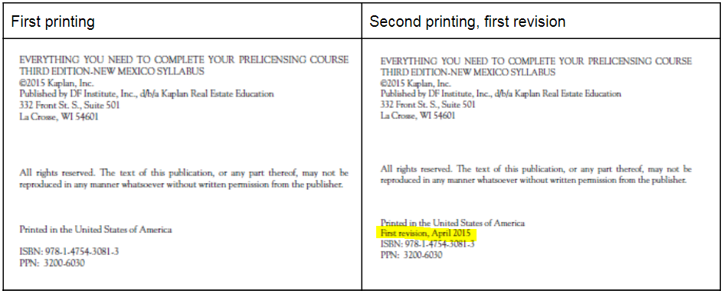

Second printing, first revision
Page/Location | Reads Now | Should Be
63, item 15 | 15. D | 15. C

Third printing, second revision
Page/Location | Reads Now | Should Be
181, PAGE 3, 3rd item | real property | personal property

Page/Location | Reads Now | Should Be
84 question 30 | A purchase agreement would likely be voidable under all of these circumstances EXCEPT:  A. the purchaser is a minor.  B. the seller signed under duress.  C. the buyer didn’t read or understand the contract.  D. the seller made a material misrepresentation to the buyer. | A tenant has two years left on a five-year lease of commercial property. The tenant assigns the remaining two years of the lease. To whom did the tenant assign the lease?  A. The landlord  B. The new tenant  C. The lessor  D. None of these
89, answer 24 | D Contracts with a minor are voidable by the minor, not the adult. | B A minor generally cannot make a contract concerning real estate. Such a contract would be void.
89, answer 29 | A The contract is voidable because the minor could disaffirm it. | B The contract is void because a minor generally cannot make a contract concerning real estate.
89, answer 30 | C Failure to read the contract does not allow a party to withdraw. | B An assignment of a lease transfers the rights of the original tenant to the new tenant for the remainder of the term of the lease.

