Errata

At Dearborn™ Real Estate Education, we are proud of our reputation for providing the most complete, current, and accurate information in all our products. We are committed to ensuring the kind of quality you rely on. Please note the following changes, which will be reflected in the next printing of Connecticut Real Estate Practice & Law, 15E.

To use this document, you will need to know which revision of the book you have. The revision is indicated on the copyright page, which is on the second page of the book.

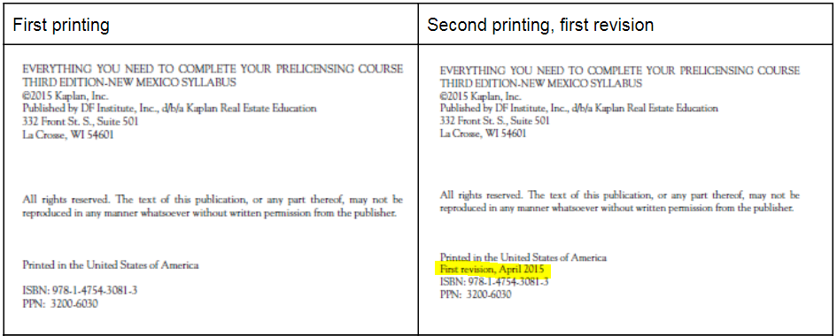

Page/Location | Reads Now | Should Be
p. 3 Broker | All persons that have an ownership interest in a legal entity that is licensed as a broker must hold either a broker or salesperson license, with licensed brokers owning at least 51% of the entity. | All persons that have an ownership interest in a legal entity that is licensed as a broker who engage in the real estate brokerage business must hold either a broker or salesperson license, with licensed brokers owning at least 51% of the entity
p. 9 Disclosure of Agency to Unrepresented Persons | Note that changes regarding this legislative decision were recently made effective January 1, 2020 | Deleted
p. 10 Disclosure of Agency to Unrepresented Persons | This disclosure must be given before the buyer or tenant signs the purchase contract or lease. | This disclosure must be given at the beginning of the first personal meeting concerning the unrepresented party's needs.
p. 26 | B. all owners of the LLC have either a broker or salesperson license, and a majority of the entity is owned by brokers. | B. all active owners of the LLC have either a broker or salesperson license, and a majority of the entity is owned by brokers.
p. 131 Learning Objectives | Identify activities that would result in a suspension of revocation of a license and how it relates to the  Real Estate Guaranty Fund. | Identify activities that would result in a suspension or revocation of a license and how it relates to the  Real Estate Guaranty Fund.
p. 259 Unit 1 Quiz Answer Key | (3) A legal entity that engages in the real estate business in Connecticut must hold a valid broker’s license. The majority of ownership in the entity must be held by Connecticut licensed brokers, and all owners must hold either a Connecticut broker’s or salesperson’s license. | (3) A legal entity that engages in the real estate business in Connecticut must hold a valid broker’s license. The majority of ownership in the entity must be held by Connecticut licensed brokers, and all active owners must hold either a Connecticut broker’s or salesperson’s license.

