Errata

At Dearborn™ Real Estate Education, we are proud of our reputation for providing the most complete, current, and accurate information in all our products. We are committed to ensuring the kind of quality you rely on. Please note the following changes, which will be reflected in the next printing of Modern Real Estate Practice in New York for Salespersons, Thirteenth Edition.

To use this document, you will need to know which revision of the book you have. The revision is indicated on the copyright page, which is on the second page of the book.

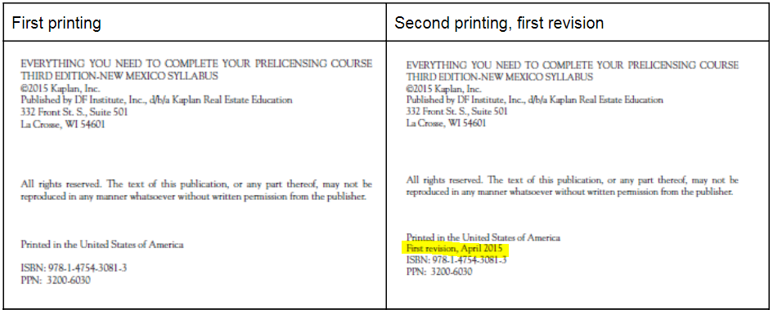
First Printing
Page/Location | Reads Now | Should Be
10, 1st paragraph under Licensing Procedure | $50 license fee | $55 license fee
12, Figure 1.3: Real Estate Salesperson Application |  | REPLACED by current application form found here: https://www.dos.ny.gov/forms/licensing/0022-f-a.pdf
31, 1st paragraph | $50 for a salesperson and $150 for a broker | $55 for a salesperson and $155 for a broker
Second Printing, First Revision
Page/Location | Reads Now | Should Be
443, 2nd paragraph | A primary or principal residence is newly defined as the location where a taxpayer has resided for at least five out of the previous eight years… | A primary or principal residence is defined as the location where a taxpayer has resided for at least two out of the previous five years…
590, Unit 20 | 1. D | 1. C

