Errata

At Dearborn™ Real Estate Education, we are proud of our reputation for providing the most complete, current, and accurate information in all our products. We are committed to ensuring the kind of quality you rely on. Please note the following changes, which will be reflected in the next printing of California Real Estate Finance 10th Edition.

To use this document, you will need to know which revision of the book you have. The revision is indicated on the copyright page, which is on the second page of the book.

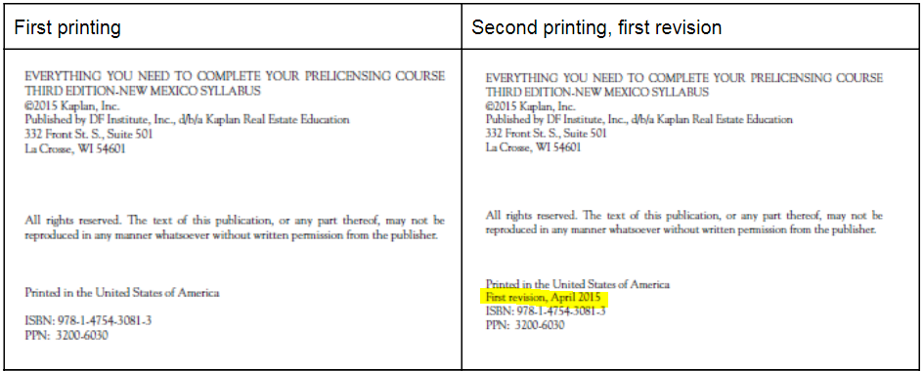

Page/Location | Reads Now | Should Be
192, paragraph 5 | ... the inducement to panic selling, also known as steering | ... the inducement to panic selling, also known as blockbusting
224, Secured Overnight Financing Rate (SOFR) | It appears that the Liboras index may be phased out and the newer index of SOFR may become the index of choice over time. | It appears that the Libor as index may be phased out and the newer index of SOFR may become the index of choice over time.
398, Trading on Seller's Equity | In effect, the seller would be securing the $35,000 cash plus the junior loan for $20,000 as agreed… | In effect, the seller would be securing the $35,000 cash plus the junior loan for $40,000 as agreed…

