Errata

At Dearborn™ Real Estate Education, we are proud of our reputation for providing the most complete, current, and accurate information in all our products. We are committed to ensuring the kind of quality you rely on. Please note the following changes, which will be reflected in the next printing of Modern Real Estate Practice in New York for Salespersons, Thirteenth Edition.

To use this document, you will need to know which revision of the book you have. The revision is indicated on the copyright page, which is on the second page of the book.

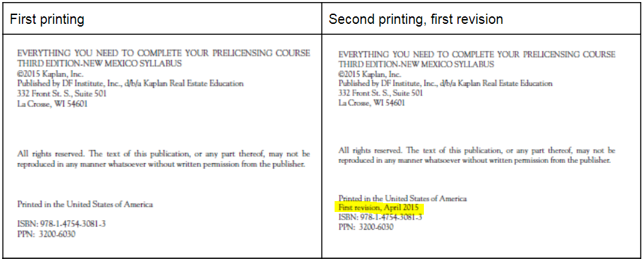
First Printing
Page/Location | Reads Now | Should Be
10, 1st paragraph under Licensing Procedure | $50 license fee | $55 license fee
12, Figure 1.3: Real Estate Salesperson Application |  | REPLACED by current application form found here: https://www.dos.ny.gov/forms/licensing/0022-f-a.pdf
31, 1st paragraph | $50 for a salesperson and $150 for a broker | $55 for a salesperson and $155 for a broker
Second Printing, First Revision
Page/Location | Reads Now | Should Be
Page 26, Licensees From Other States | Reciprocal agreements are reached between states that are willing to recognize each other’s license laws as well as the requirements needed to achieve licensing within their jurisdictions.  All states devise their statutory laws somewhat differently, but a majority of the requirements for achieving licensing are the same throughout the United States. As a result, state A can reach a reciprocity agreement with state B that recognizes licenses attained in either state as entitling the license holder to be issued a license by the other state. When this type of agreement between states exists, in order to achieve a license within another state after having received a license in one, no additional education or testing is required. At this time, New York has reciprocal agreements with nine states (see Figure 1.5); however, certain requirements must be fulfilled, as discussed in the section “Licensing Nonresidents.”  Under certain conditions, household members of members of the armed forces may be granted a New York real estate license even where there is no reciprocity if the individual is licensed in another state and now lives in New York. If granted a New York license, they must complete at least 11 of the required 22½ hours of continuing education within the first year, three hours of which must be about the New York License Law and related regulations. Contact DOS for details. | Note: Due to state law changes in 2023, this section was updated. The text and figure have been replaced with the following:  Reciprocal agreements are reached between states that are willing to recognize each other's license laws as well as the requirements needed to achieve licensing within their jurisdictions.  All states devise their statutory laws somewhat differently, but a majority of the requirements for  achieving licensing are the same throughout the United States. As a result, state A can reach a  reciprocity agreement with state B that recognizes licenses attained in either state as entitling the license holder to be issued a license by the other state. When this type of agreement between states  exists, in order to achieve a license within another state after having received a license in one, no additional education or testing is required. Due to recent changes to New York State Real Property law increasing the educational requirements to obtain a real estate salesperson or broker license, New York  no longer has reciprocity with any other state.  If you completed qualifying education outside of New York State, you may request a waiver of the course(s) required for a New York State license.  To request a waiver, you must submit:  • A course description  • Proof of course completion  • A detailed outline listing the topics and hours completed  The request and documentation can be emailed to dosedmailing@dos.ny.gov
443, 2nd paragraph | A primary or principal residence is newly defined as the location where a taxpayer has resided for at least five out of the previous eight years… | A primary or principal residence is defined as the location where a taxpayer has resided for at least two out of the previous five years…
590, Unit 20 | 1. D | 1. C

