Errata

At Dearborn™ Real Estate Education, we are proud of our reputation for providing the most complete, current, and accurate information in all our products. We are committed to ensuring the kind of quality you rely on. Please note the following changes, which will be reflected in the next printing of California Real Estate Escrow and Title, First Edition.

To use this document, you will need to know which revision of the book you have. The revision is indicated on the copyright page, which is on the second page of the book.

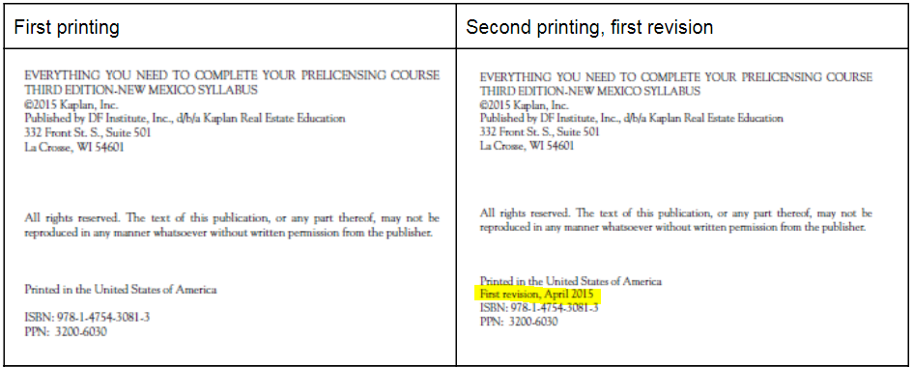

Page/Location | Reads Now | Should Be
Page 10/4th paragraph | Joint tenants cannot sell or transfer their interest without the consent of the others. | Joint tenants can sell or transfer their interest without the consent of the others.
Page 52/question 10, answer A | typically acceptable to existing lenders | typically unacceptable to existing lenders.
p. 95/9.a. | the conditions under which a lender will approval a loan. | the conditions under which a lender will approve a loan.
Page 138, question 5 | The CLTA standard title policy | The CLTA standard title policy with endorsements
Page 184, 4th paragraph | ...and an additional waiting period of three days before loan signing... | ...and an additional waiting period of three business days before loan signing...
page 193, question 3 | Under the general education requirements for obtaining a California real estate salesperson license, and individual must | ...an individual must
pg 224, 4th para | Foreign Investments of Real Property Tax Act... | Foreign Investments in Real Property Tax Act..
pg 244, question 9, answer c | Foreign Investment of Real Property Tax Act. | Foreign Investment in Real Property Tax Act
Page 272, para 2 | ...and an additional three day waiting period. | ...and an additional three business day waiting period.
Page 286, question 7, answer c | escrow may not close for three days after receipt of the new TIL. | escrow may not close for three business days after receipt of the new TIL.
Page 301, last paragraph | ...based on a simple formula of $0.55 per $500 . | ...based on a simple formula of $0.55 per $500 or fraction of $500 .
Page 425, paragraph 3 | A coordinate may be written as 65⸰, 32 minutes, and 15 seconds. It may also be written as decimals: 65.5375 – verbalized as 65 point 5375 degrees | A coordinate may be written as 65⸰, 32 minutes, and 15 seconds. It may also be written as decimals: 65.5325 – verbalized as 65 point 5325 degrees,
Page 440, last paragraph | Among legal issues of importance regarding short sales is California Civil Code Section 580 (e), | Among legal issues of importance regarding short sales is California Code of Civil Procedure Section 580 (e),
Page 445, para 1 | It is this clause under which the law allows the lender to foreclosure without a court action. | It is this clause under which the law allows the lender to foreclose without a court action.
Pg 448, Question 3, answer b | both owner-occupied and investment homes having one to four units. | both owner-occupied and investment property having one to four dwelling units.
Page 451, chapter 1, answer 9 | c Fee simple estates are inheritable. (p. 12) | d All of these. (p. 12)
Page 456, Chapter 9, answer 9 | c YSP is the yield spread premium paid to broker. (p. 225) | c FIRPTA stands for the Foreign Investment in Real Property Tax Act. (p. 224)
pg 456, Chapter 9, answer 10 | a Signing an affidavit of occupancy warns the borrower of possible mortgage fraud. (p. 224) | a Those not of an established form, or used in general practice. (p. 225)
Page 457, chapter 11, answer 7 | d TIL law requires that escrow not close for three days if the borrower’s loan rate increases 0.125% or more than the amount first disclosed. (p. 272) | d TIL law requires that escrow not close for three business days if the borrower’s loan rate increases or decreases by 0.125% or more than the amount first disclosed. (p. 272)
Page 458, chapter 12, answer 9 | a To find the sales price, divide the transfer tax by $0.55 and multiply by $500. (p. 301) | a To find the sales price, divide the transfer tax by $0.55 and multiply by $500 and add .55 for any fraction of $500. (p. 301)
Page 460, Chapter 16, answer 10 | The escrow holder must obtain a written release from FTB, EDD, or the Board of equalization for a buyer liable for taxes to any of them. (p. 403) | The escrow holder must obtain a written release from the department to whom the taxes are owed prior to allowing the escrow to close in order for the buyer to avoid liability. (p. 403)
Page 461, chapter 18, answer 3 | a The California foreclosure time line applies to one-to-four unit owner-occupied homes. (p. 441) | a The California foreclosure time line applies to all one-to-four unit residential property. (p. 441)
page 513, FIRPTA | Short for Federal Investment of Real Property Tax Act, | Short for Foreign Investment in Real Property Tax Act,

