Errata

At Dearborn™ Real Estate Education, we are proud of our reputation for providing the most complete, current, and accurate information in all our products. We are committed to ensuring the kind of quality you rely on. Please note the following changes, which will be reflected in the next printing of Connecticut Real Estate Practice & Law, 15E.

To use this document, you will need to know which revision of the book you have. The revision is indicated on the copyright page, which is on the second page of the book.

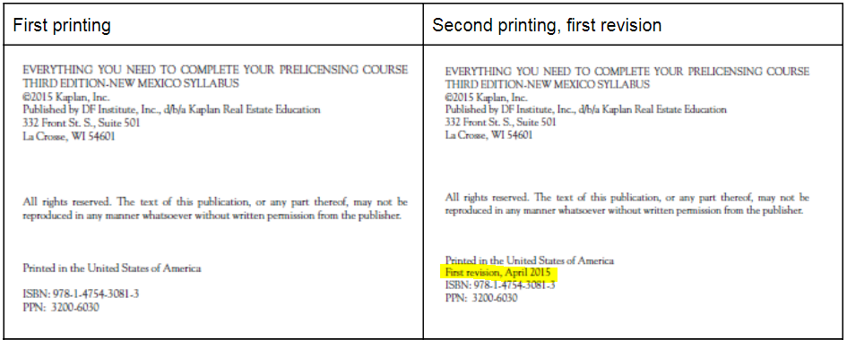

Page/Location | Reads Now | Should Be
p. 9 Disclosure of Agency to Unrepresented Persons | Note that changes regarding this legislative decision were recently made effective January 1, 2020 | Deleted
p. 10 Disclosure of Agency to Unrepresented Persons | This disclosure must be given before the buyer or tenant signs the purchase contract or lease. | This disclosure must be given at the beginning of the first personal meeting concerning the unrepresented party's needs.

