Errata

At Dearborn™ Real Estate Education, we are proud of our reputation for providing the most complete, current, and accurate information in all our products. We are committed to ensuring the kind of quality you rely on. Please note the following changes, which will be reflected in the next printing of Essentials of Real Estate Finance, Fifteenth Edition.

To use this document, you will need to know which revision of the book you have. The revision is indicated on the copyright page, which is on the second page of the book.

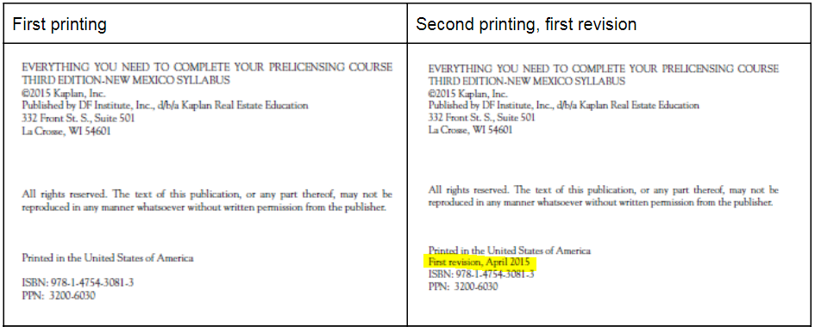

Page/Location | Reads Now | Should Be
Page 28, first paragraph under Federal Funds Rate | The Fed also lends money to its member banks without requiring any collateral. | The Fed also allows member banks to loan money to each other without requiring any collateral.
Page 166, end of second paragraph under Maximum Loan Limitations |  | [Adding example for clarity]  For example, if the median house price for the area was $725,000, the loan limit would still be $625,500, which is the loan limit for high-cost areas.
Page 119, Question 14 | A contract for deed may also be known as | A contract for deed would NOT be known as
Page 292, Unit 8 Review Questions Answer Key, #14 | 14. b The equation is as follows: annual income of $48,000 ÷12 = $4,000 × 43% = $1,440 | 14. c The equation is as follows: annual income of $48,000 ÷12 = $4,000 × 43% = $1,720
Page 293, Unit 9 Review Questions Answer Key, #2 | 2. c After seven or eight years, most people either sell or refinance | 2. d 10% new credit, 15% length of credit history, 30% amount owed.

