Errata

At Dearborn™ Real Estate Education, we are proud of our reputation for providing the most complete, current, and accurate information in all our products. We are committed to ensuring the kind of quality you rely on. Please note the following changes, which will be reflected in the next printing of Everyday Ethics in Real Estate, Second Edition.

To use this document, you will need to know which revision of the book you have. The revision is indicated on the copyright page, which is on the second page of the book.

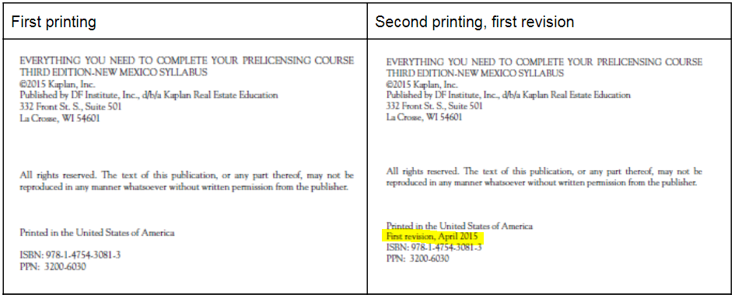

Page/Location | Reads Now | Should Be
47 | SOP 12-10 was amended in 2013 to specifically prohibit presenting content developed by others without either attribution or permission or to otherwise mislead consumers. | SOP 12-10 prohibits presenting content developed by others without either attribution or permission or otherwise misleading consumers, including use of misleading images.
103-110 (Replace entire Code of Ethics in Appendix) | Code of Ethics and Standards of Practice of the NATIONAL ASSOCIATION OF REALTORS® Effective January 1, 2017 | Code of Ethics and Standards of Practice of the NATIONAL ASSOCIATION OF REALTORS® Effective January 1, 2018

