Errata

At Dearborn™ Real Estate Education, we are proud of our reputation for providing the most complete, current, and accurate information in all our products. We are committed to ensuring the kind of quality you rely on. Please note the following changes, which will be reflected in the next printing of Florida Real Estate Principles, Practices, & Law, 43rd Edition.

To use this document, you will need to know which revision of the book you have. The revision is indicated on the copyright page, which is on the second page of the book.

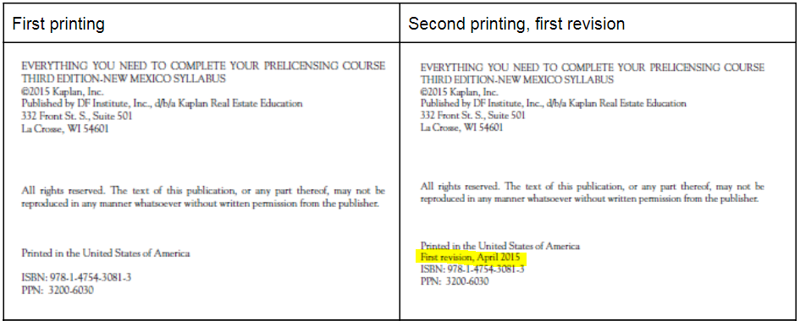

Page/Location | Reads Now | Should Be
37, fifth bullet | The continuing education requirement includes a three-hour core law course and a three-hour ethics and business practices course. | The continuing education requirement includes a three-hour core law course and a three-hour business ethics course.
51 | The DBPR places the licenses of any sales associates and broker associates registered under the penalized broker on involuntary inactive status. The sales associates and broker associates are free to seek another employer and register as active under a new employer. A sales associate’s license is returned to active status as soon as a new employer is chosen and the information is filed with the DBPR. Alternatively, if the sales associate chooses to not practice real estate, the licensee can change the license status to voluntary inactive within the licensee’s online DBPR account. | The DBPR places the licenses of any sales associates and broker associates registered under the penalized broker on inactive status. The sales associates and broker associates are free to seek another employer and register as active under a new employer. A sales associate’s license is returned to active status as soon as a new employer is chosen and the information is filed with the DBPR.

