Errata

At Dearborn™ Real Estate Education, we are proud of our reputation for providing the most complete, current, and accurate information in all our products. We are committed to ensuring the kind of quality you rely on. Please note the following changes, which will be reflected in the next printing of Guide to Passing the PSI Real Estate Exam, Eighth Edition.

To use this document, you will need to know which revision of the book you have. The revision is indicated on the copyright page, which is on the second page of the book.

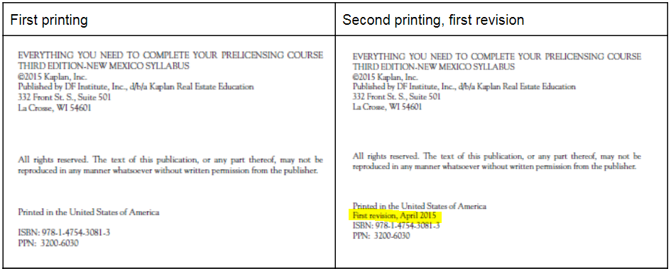

Page/Location | Reads Now | Should Be
Page 4, PSI Test Specifications for Salespeople | Property Ownership (10 questions)  Land-Use Controls and regulations (5 questions)  Valuation and Market Analysis (7 questions)  Financing (8 questions)  General Principles of Agency (11 questions)  Property Disclosures (7 questions)  Contracts (18 questions)  Leasing and Property Management (5 questions)  Transfer of Title (7 questions)  Practice of Real Estate (14 questions)  Real Estate Calculations (8 questions) | Property Ownership (8%, approximately 6-7 questions)  Land-Use Controls and regulations (5%, approximately 4 questions)  Valuation and Market Analysis (7%, approximately 5-6 questions)  Financing (10%, approximately 8 questions)  General Principles of Agency (13%, approximately 10-11 questions)  Property Disclosures (6%, approximately 4-5 questions)  Contracts (17%, approximately 13-14 questions)  Leasing and Property Management (3%, approximately 2-3 questions)  Transfer of Title (8%, approximately 6-7 questions)  Practice of Real Estate (14 questions)  Real Estate Calculations (10%, approximately 8 questions)
Page 5, Broker Examination | While the salesperson exam contains 80 one-point, multiple-choice items, the broker exam is composed of 75 one-point, multiple choice items as well as five two-point, multiple-choice items. After January 1, 2019, these exams will be longer. | While the salesperson exam contains 80 one-point, multiple-choice items, the broker exam is composed of 75 one-point, multiple-choice items and five two-point, multiple-choice items. Beginning January 1, 2019, longer versions of the salesperson and broker examinations will be available for states to adopt. The longer version of the salesperson examination is composed of 100 one-point, multiple-choice items. The longer version of the broker examination is composed of 80 one-point, multiple-choice items and 10 two-point, multiple-choice items.
Page 5, PSI Test Specifications for Broker | Property Ownership (10 questions)  Land-Use Controls and regulations (5 questions)  Valuation and Market Analysis (7 questions)  Financing (8 questions)  General Principles of Agency (11 questions)  Property Disclosures (7 questions)  Contracts (18 questions)  Leasing and Property Management (5 questions)  Transfer of Title (7 questions)  Practice of Real Estate (14 questions)  Real Estate Calculations (8 questions) | Property Ownership (10%, approximately 8 questions)  Land-Use Controls and regulations (5%, approximately 4 questions)  Valuation and Market Analysis (7%, approximately 5-6 questions)  Financing (8%, approximately 6-7 questions)  General Principles of Agency (11%, approximately 8-9 questions)  Property Disclosures (7%, approximately 5-6 questions)  Contracts (18%, approximately 14-15 questions)  Leasing and Property Management (5%, approximately 4 questions)  Transfer of Title (7%, approximately 5-6 questions)  Practice of Real Estate (14%, approximately 11-12 questions)  Real Estate Calculations (8%, approximately 6-7 questions)

